Μάθημα 46

- Βρες πόσο κάνουν ανεβαίνοντας ή κατεβαίνοντας 1 - 1

5 + 2 =.......
6 + 3 =.......
4 + 2 =.......
5 + 4 =.......
7 + 2 =.......

17 + 2 =.......
18 + 1 =.......
12 + 4 =.......
13 + 3 =.......
11 + 5 =.......
8 - 2 =.......
9 - 4 =.......
7 - 3 =.......
8 - 5 =.......
9 - 6 =.......

16 - 2 =.......
19 - 5 =.......
17 - 4 =.......
18 - 3 =.......
19 - 3 =.......

- Λογάριασε τώρα πιο προσεκτικά: Αν δυσκολευτείς,
κρύψε με το δαχτυλάκι σου τις Δεκάδες.

5 + 3 =.......
15 + 3 =.......
25 + 3 =.......
35 + 3 =.......
45 + 3 =.......
6 + 2 =.......
16 + 2 =.......
26 + 2 =.......
36 + 2 =.......
46 + 2 =.......

9 - 2 =.......
19 - 2 =.......
29 - 2 =.......
39 - 2 =.......
49 - 2 =.......
Τι παρατηρείς;

8 - 3 =.......
18 - 3 =.......
28 - 3 =.......
38 - 3 =.......
48 - 3 =.......

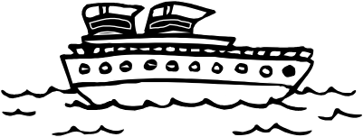
- Θυμήσου το προηγούμενο κόλπο και προσπάθησε να βρεις τι λείπει:

5 + ........ = 9
15 + ........ =19

4 + ........ = 7
14 + ........ =17

3 +........= 5
13 +....... =15
6 +........ = 9
16 +........ =19

2 + ........ = 8
12 + .........=18

4 + ........ = 6
14 + ........ =16

9 - ........ = 7
19 - ........ =17

8 - ........ = 5
18 - ........ =15

7 - ........ = 3
17 - ........ =13

6 -........ = 2
16 -........ =12

7 - ........ =5
17 - ........ =15

9 -........ =4
19 -........ =14

Όνομα:
www.grafoulis.gr

