Hello my dear students! I hope you are fine! Here is some new material to study, so as not to forget whatever you have learnt till now.
Many kisses,
Miss Rania

COUNTABLE - UNCOUNTABLE NOUNS (ANSWERS)
1. a. some , b. some , c. any , d. any , e. some , f. any , g. any , h. any , i. a ,
j. some
2. a. There is a little milk in the fridge. b. I have very few apples. I can't make an applepie. c. There is a lot of ice-cream in the bowl. d. Can I have a packet of flour, please? e. I would like a dozen of eggs, please. f. There aren't many potatoes left.

PRESENT SIMPLE / PRESENT CONTINUOUS

1. Read and circle True or False. (Διάβασε και κύκλωσε Σωστό ή Λάθος.)
I like sports. I play tennis every weekend and I watch tennis matches on TV every time there is one! I also play basketball on Fridays. I am not very good so I am learning with a trainer. Right now I am looking for information about famous players on the internet. My sister doesn’t like sports. Every weekend she stays at home and watches TV! At the moment she is helping our dad cook dinner in the kitchen.
a. I play tennis every Saturday and Sunday. True / False
b. I’m playing tennis now. True / False
c. I play basketball every day. True / False
d. I’m using the computer now. True / False
e. My sister is watching TV now. True / False

[We use the present simple to talk about routines – what you do every day or every week. We use the present continuous to talk about things you are doing now. e.g.I watch cartoons every day. I’m watching a film now.]

2. Put the verbs in the Present Simple or Present Continuous. (Βάλε τα ρήματα σε Ενεστώτα Απλό ή Ενεστώτα Διαρκείας.)
a. I ___________________ a lot at weekends. (sleep)
b. At the moment our two cats _________________. (sleep)
c. I ___________________ computer games every day! (not play)
d. I ___________ outside with my friends now because it’s raining. (not play)
e. Right now my mum _____________________ a magazine. (read)
f. My dad usually ___________ a bedtime story to me and my brother. (read)
g. Now we ____________________ our favourite cartoon. (watch)
h. On Sundays we ______________________ TV in the evening. (not watch)

3. Find the mistake and write the correct sentence. (Βρες το λάθος και γράψε την πρόταση σωστά.)
a. We’re make a cake for mum’s birthday now. ________________________
b. Every Sunday I’m calling my grandmother. _________________________
c. At the moment my sister doesn’t studying English. ___________________
d. My parents take the dog for a walk right now. _______________________
e. My brother is never eating peanuts because he’s allergic. _____________
COMPARATIVE AND SUPERLATIVE
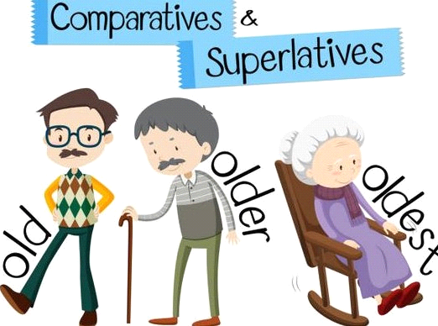
1. Write sentences about the animals using comparatives and superlatives.(Γράψε προτάσεις για τα ζώα με συγκριτικό και υπερθετικό.)
a. fast: mouse / cheetah / cat
e.g -The cat is faster than the mouse but the cheetah is the fastest of all.
b. intelligent: dolphin / dog / bird ____________________________________________________________
c. short: giraffe / horse / penguin ____________________________________________________________
d. heavy: hippo / elephant / cow ____________________________________________________________
e. dangerous: shark / wolf / rabbit ____________________________________________________________
f. slow: tortoise / spider / duck ____________________________________________________________

2. Choose the correct sentence. (Διάλεξε την σωστή πρόταση.)
a. My sister is taller than me.
My sister is more taller than me.
My sister is more tall than me.
b. I think English homework is the easiest than History homework.
I think English homework is more easy than History homework.
I think English homework is easier than History homework.
c. The tiger is beautiful as the leopard.
The tiger is more beautiful as the leopard.
The tiger is as beautiful as the leopard.
d. The river Nile is longer than the Mississippi.
The river Nile is more long than the Mississippi.
The river Nile is the most longer than the Mississippi.
e. The air in the village isn't most polluted as the air in the city.
The air in the village isn't so polluted as the air in the city.
The air in the village isn't more polluted as the air in the city.

3. Find the mistake and write the correct sentence. (Βρες το λάθος και γράψε την πρόταση σωστά.)
a. This book is most interesting than my homework! ________________________________________________
b. My brother is more bad at tennis than me. ________________________________________________
c. My phone is most expensive thing I have. ________________________________________________
d. The cheetah is the most fast animal. ________________________________________________
e. The blue whale is the most heaviest animal. ________________________________________________

