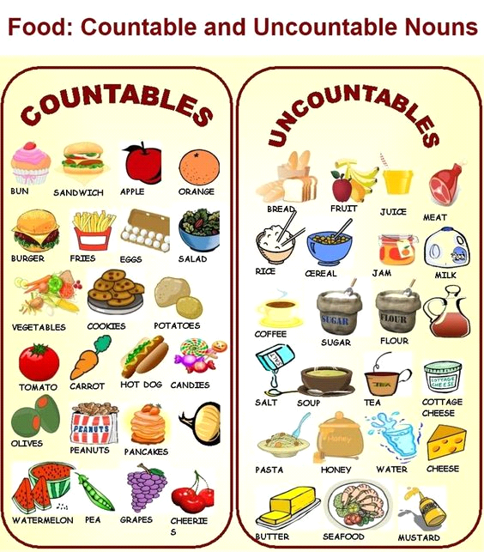
COUNTABLE / UNCOUNTABLE NOUNS
1. Choose the correct answer
a. I've got -------------- water in my bag. any / some / a
b. There is -------------- rice in the cupboard. any / a / some
c. There aren't ------------------ bananas on the table. any / some / a
d. Is there ----------------- orange juice? a / any / some
e. My parents gave me ---------------- new toys for my birthday. some / a / any
f. Are there ------------------- grapes in the fridge? a / some / any
g. We haven't got ---------------------- time! a / some / any
h. Do you take -------------------- sugar in your coffee? some / any / a
i. Can I have ------------------- glass of water please ? a / any / some
j. He has got ---------------------- news from his friends. any / some / a

2. Tick the correct sentence
a. There is a little milk in the fridge.
There is a few milk in the fridge.
There is a milk in the fridge.
b. I have a few apples. I can't make an applepie.
I have little apples. I can't make an applepie.
I have very few apples. I can't make an applepie.
c. There is a lot of ice-cream in the bowl.
There is any ice-cream in the bowl.
There is a few ice-cream in the bowl.
d. Can I have a bottle of flour, please?
Can I have a piece of flour, please?
Can I have a packet of flour, please?
e. I would like a kilo of eggs, please.
I would like a dozen of eggs, please.
I would like a slice of eggs, please.
f. There aren't much potatoes left.
There aren't a lot potatoes left.
There aren't many potatoes left.

