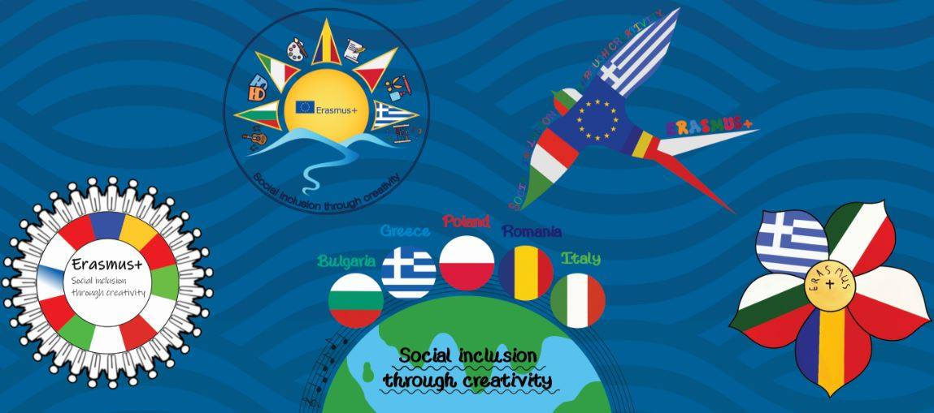

**Social inclusion through creativity**

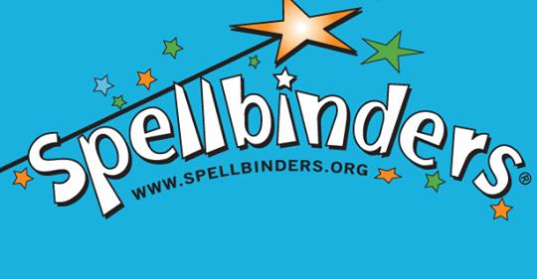

**The three brothers and the golden apples (Bulgarian story)**

**Activities with year six students**

The fairy tale was first read in the classroom and discussed with the students. An attempt was made to look for similarities with fairy tales of our country.

The children found that there are similarities with a Greek legend titled “Saint George and the dragonslayer.   
Then they started drawing in order to illustrate the fairy tale and they also made the tree with golden apples.

In the end they created a very entertaining game of trust which they played it in the school yard.

