Theseus and Minotaur
COMPLETE THE STORY (collaborative creative writing )
In the beginning a piece of the story was given to the children. Then they were divided into 3 groups and wrote the sequel and the end of the story.

Beginning of the story
I am ashamed to look you in the eyes. I do not know how you will get it, but I am the Minotaur. I know exactly what you think of me. It is written in the mythology you learn in school.
From the toes to the neck I am no different from a normal person. But my head is a little different: it's a bull's head. Α man with a bull's head!
It’s a lie! Do not believe it! But saying it continuously it remained so. I almost believed it too. One night as I bent down to drink water in the lake, I suddenly saw my face.

First group

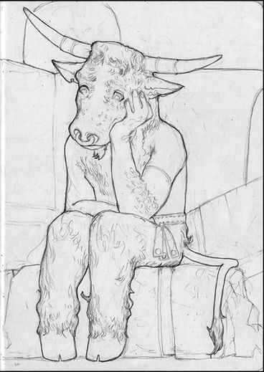

I was stunned at the sight of my face and I finally fell into the water. I sank in as I could not float. Everything around me got dark. Suddenly a figure slowly began to be seen through the darkness.
She started talking without opening her mouth.
He told me: You will be able to get the desired human head if you fulfill the following mission.
The purpose of your mission is to make friends and make people accept that you have this weird head. This is your mission. Of course if you want. I replied that I accept to undertake the mission.
The very next day I decided to get out of the maze and try to get at most two or three friends who do not panic when they see me.
This required a lot of thought. Finally I started walking towards the exit. As soon as I reached half a meter before the exit door, a strong light blinded me.
I was not used to strong sunlight. After a few minutes I got used to it and went out.

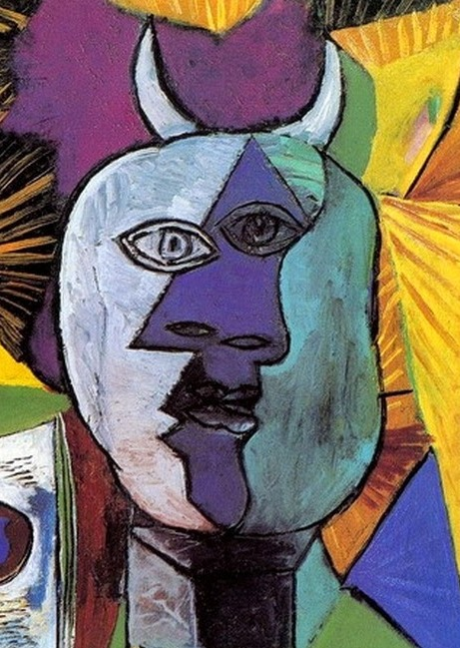

When the passers-by saw me, they were all scared and left, except for a child who started to approach me slowly.
As soon as he reached me, he hesitated to get closer to me. Finally I approached him.
- Hello child, I told him.
- Hello, he shouted at me.
- My name is Minotaur, and yours?
- My name is Apostolis or Tolis, he answered me with a little fear in his eyes.
- Nice to meet you. There is no reason to be afraid of me. I will not eat you!
Then he started talking to me about his life. He explained to me that he had no friends because he was a gypsy and everyone disliked and made fun of him for his appearance and origin. Like me. We agreed to become best friends.
One day he took me to the camp where he was staying to introduce me to another friend.
"This is the friend I was telling you about," he told me, pointing to a child in a stroller that had no legs at all.
He is also different like .... sorry, you understand what I mean!
- I do not mind his appearance. What's his name ;
- His name is Abdul and he is from Syria.
I made friends with Abdul but also with Apostolis. I completed my mission.
In the evening I decided to dive in the lake again and as I expected the figure reappeared. He told me: You should be satisfied because you completed your mission but I answered him: What should I do with the human head since it does not matter if I am different?
- Since you prefer so I will not persuade you to change your mind.
So I realized that what matters is not the appearance but the character of the person. That is why we should not make fun of others for what they are. I was very happy for my new friends.
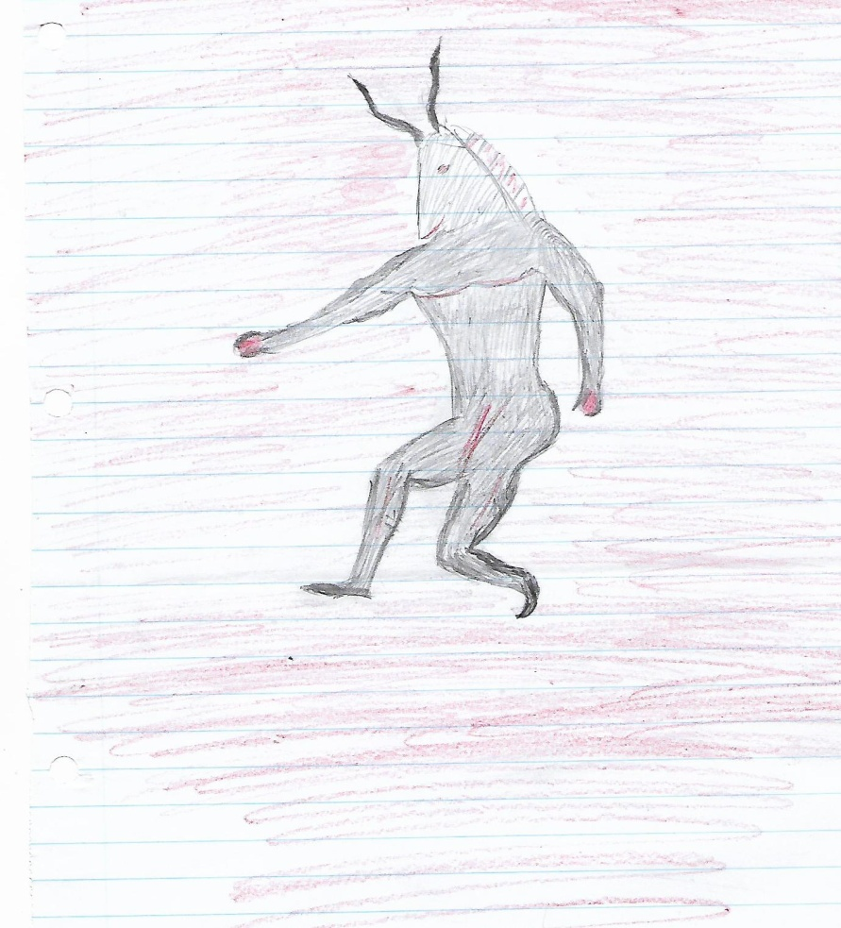
Second group

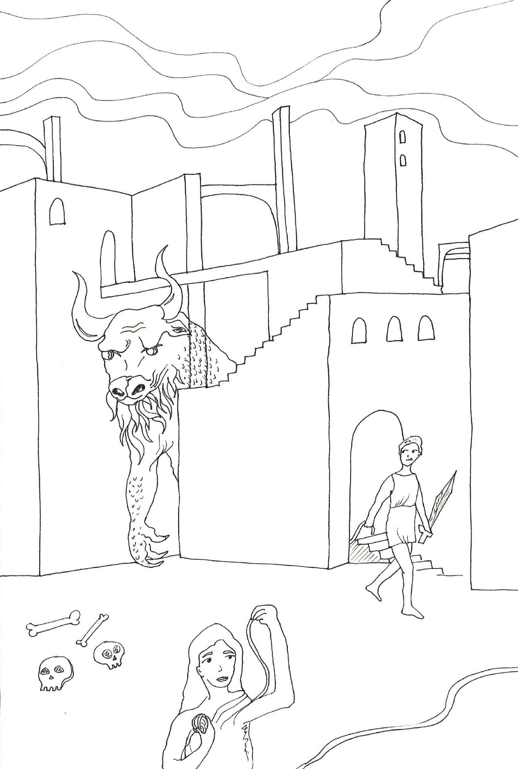

I am ashamed to look you in the eyes. I do not know how you will get it, but I am the Minotaur. I know exactly what you think of me. It is written in the mythology you learn in school.
From the toes to the neck I am no different from a normal person. But my head is a little different: it's a bull's head. Α man with a bull's head!
It’s a lie! Do not believe it! But by saying it, it remained so. I almost believed it too. One night as I bent down to drink water in the lake, I suddenly saw my face.

I stared for a long time until I realized how others saw me. I realized that they only considered me as a monster by my appearance but they did not know how I really am.
You see me and you run to hide, while I just want to be your friend.
You always avoid me because you see me so ugly that you are afraid of me. I never wanted to hurt you. I just wanted your company.
But you misunderstood me. Bulls can be scary, but I only look like a bull. My heart has no hate for the people around me.
I only ask for your love. Mythology calls me an ancient omnipotent beast that does all it can to kill. I chase people into my maze just because I want to tell them I want them to be friends. But they do not listen to me because when I try to talk to them, no human cry comes out, only moans. When I look at them, they run to hide.
King Minos called the best craftsman, Daedalus, to build the labyrinth and trap me.

Once upon a time a war broke out between the Athenians and the Cretans, where the Cretans won.
The Athenians, in order to prevent another war, promised the Cretans that every year they would send seven boys and seven girls to be the food of Minotaur.
But every time I was crying for the poor boys and girls they sent me. Fourteen innocent souls would be lost in this labyrinth. But finally one day one of the victims managed to find me and kill me. It was Theseus.
Even the Cretans themselves were afraid of me and used me for their protection. All people even today believe that if someone is ugly, he is also bad,
while if he is beautiful he is good. How wrong they are!
Everyone deserves a chance, people, animals and even supernatural beings like me! If King Minos listened to me ...
Oh right, he could not understand me. If he left me I would tell him in a pantomime that I would protect Crete from any danger with a reward but he would set me free and tell his citizens that I am not a danger to anyone!
Thus I would be known in history as the protector of Crete.

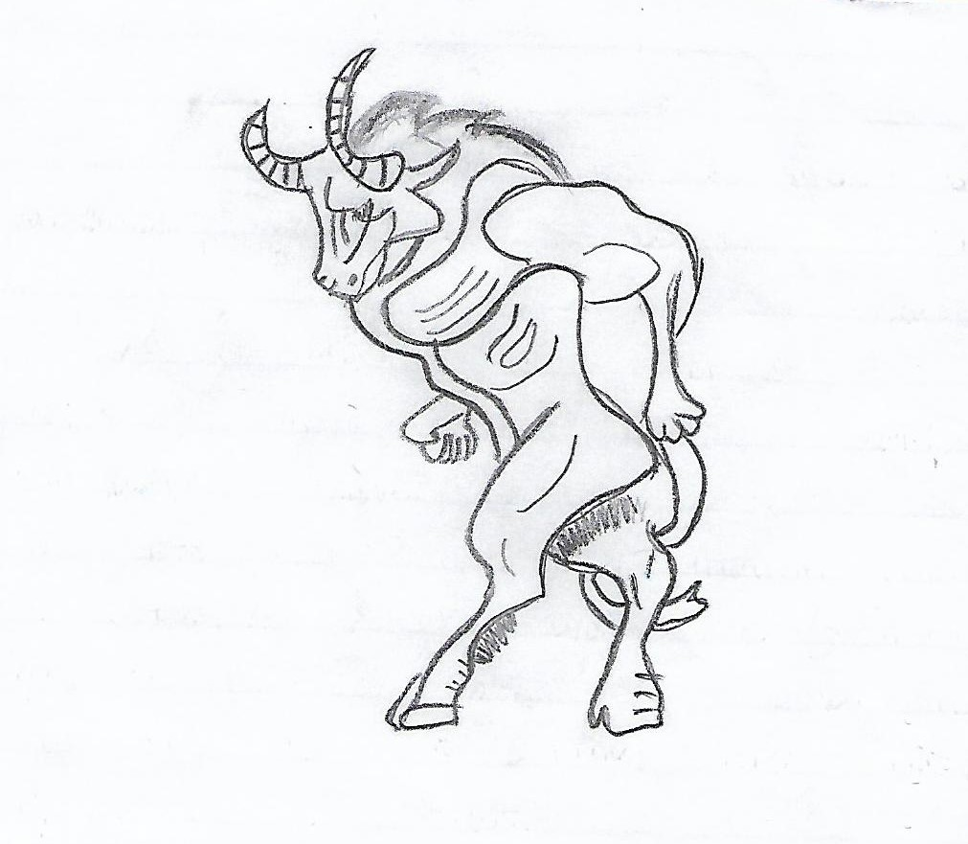

Third group

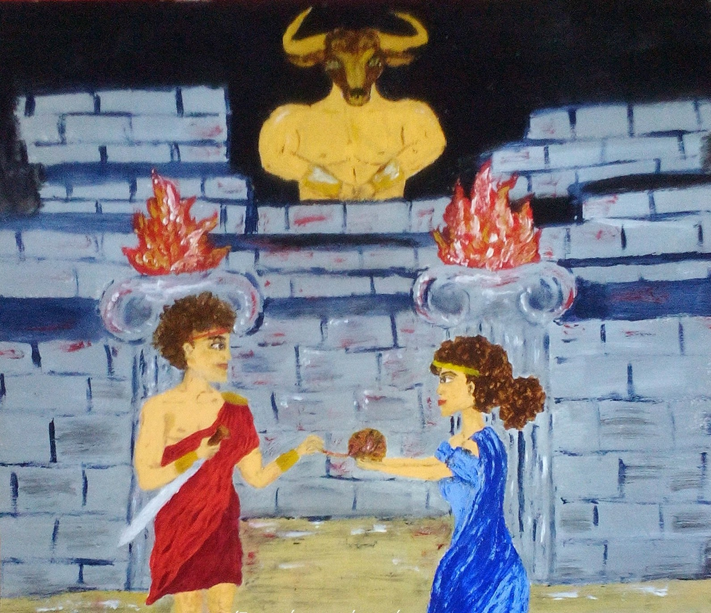

I am ashamed to look you in the eyes. I do not know how you will get it, but I am the Minotaur. I know exactly what you think of me. It is written by the mythology you learn in school.
From the toes to the neck I am no different from a normal person. But my head is a little different: it's a bull's head. Α man with a bull's head!
It’s a lie! Do not believe it! But saying it continuously, something remained so. I almost believed it too. One night as I bent down to drink water in the lake, I suddenly saw my face.
The truth is that I do not look like others. But I am not a monster, as the Athenians used to say.
Mostly they maligned and slandered me. That is why I must be ashamed now. So did my father, Minos.
With so much being heard, he was ashamed of me too. So one day he locked me in the basement of the palace. The basement is huge and has many arcades, a proper labyrinth. If you do not know the swallows well, you are lost. Of course I know them very well. I can find the way out with my eyes closed. But I do not need it.
It is better to sit alone and have my peace than to be out there and be called a monster. It is terrible to be accused unjustly.
But the time has come to unravel the thread of my story ...
I was born in Crete and I am the son of a king. My father is the famous Minos. In his years the island became a very great kingdom and everyone spoke of him with respect. He was said to be the son of Zeus and Europe.
Ιn the beginning life in Crete was very pleasant. During the festivities we played with the bulls. A lot of people gathered to see the spectacle. We ran next to the bull, grabbed it by the horns, stepped hard on their backs and with a mound we landed on the ground.
Cretan ships plowed the Mediterranean and brought all the good to the island. Then Minoan began the conquests. All the islands declared submission. Athens did the same.
My father did not like the Athenians at all. How to like them after my brother Androgeos was killed in their city. Androgeos went to Athens to take part in the games. He defeated all his opponents, but never returned to Crete.We were later told he was killed. How and what, we never learned. What is certain is that my brother was deceitfully killed in Athens. My father was very angry and wanted revenge. He enslaved Athens with his fleet and army.
In addition to the tax on goods, the Athenians had to send new people to work every year. Our palace in Knossos had over one thousand three hundred rooms. The slaves worked in the basements. They carried wine and oil in jars. They did not like it. And rightly so. Who likes to work as a slave?

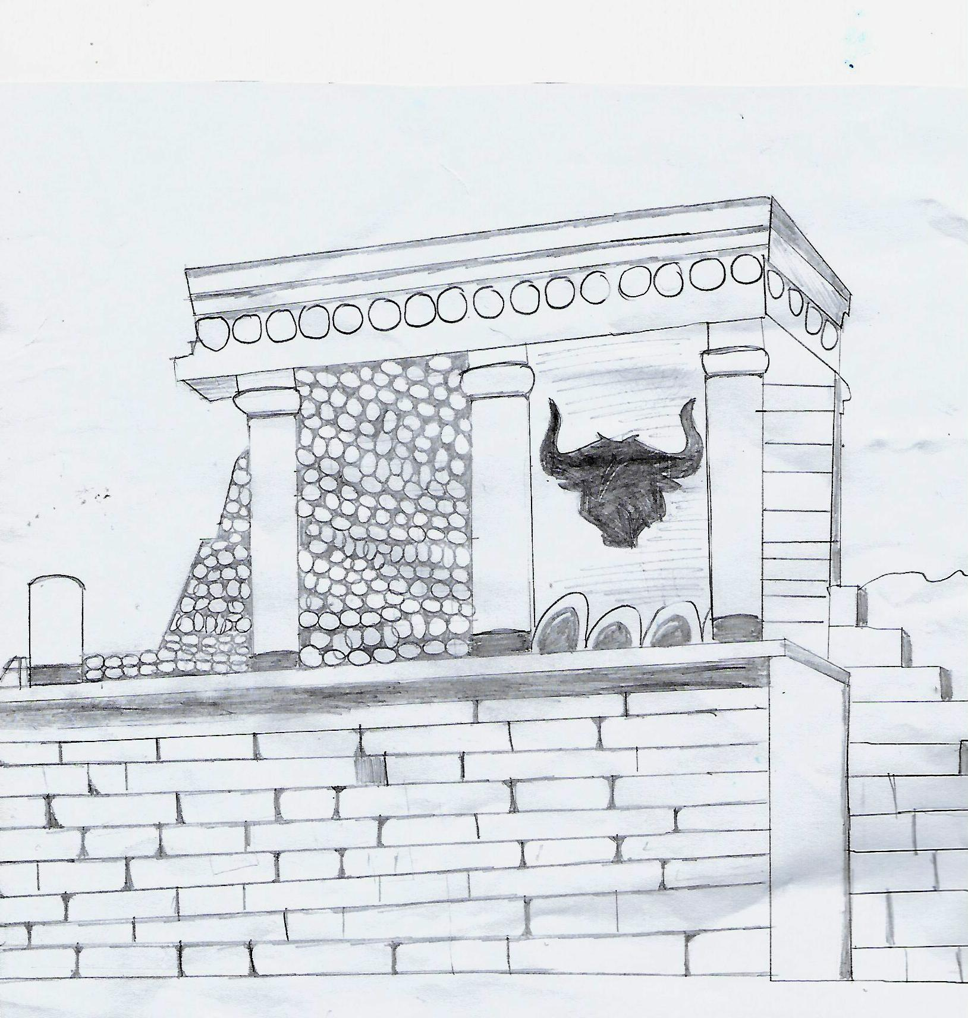

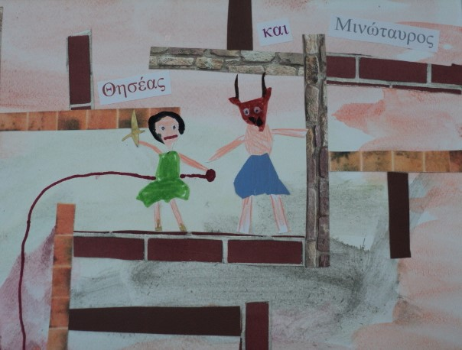
The Athenians turned against their king Aegeas: You send our children to be eaten by the Minotaur, they said to him and you have your son with you in safety. They had to send him to Crete, they told him.
Theseus came determined to put up with me. But my own sister advised him how to beat me. Theseus knew that if he defeated me it would be as if he had defeated all of Crete.

We fought in the dark. In the end he managed to beat me by stabbing me with a knife.
This is my story. Even I feel confused. What am I after all? Α person ? A monster made by the human imagination?

