Making a musical instrument

Drums!!!

**Materials for the musical instrument**

* 1 can (from coffee or baby milk)
* 1 piece of paper
* Glue
* Scissors
* 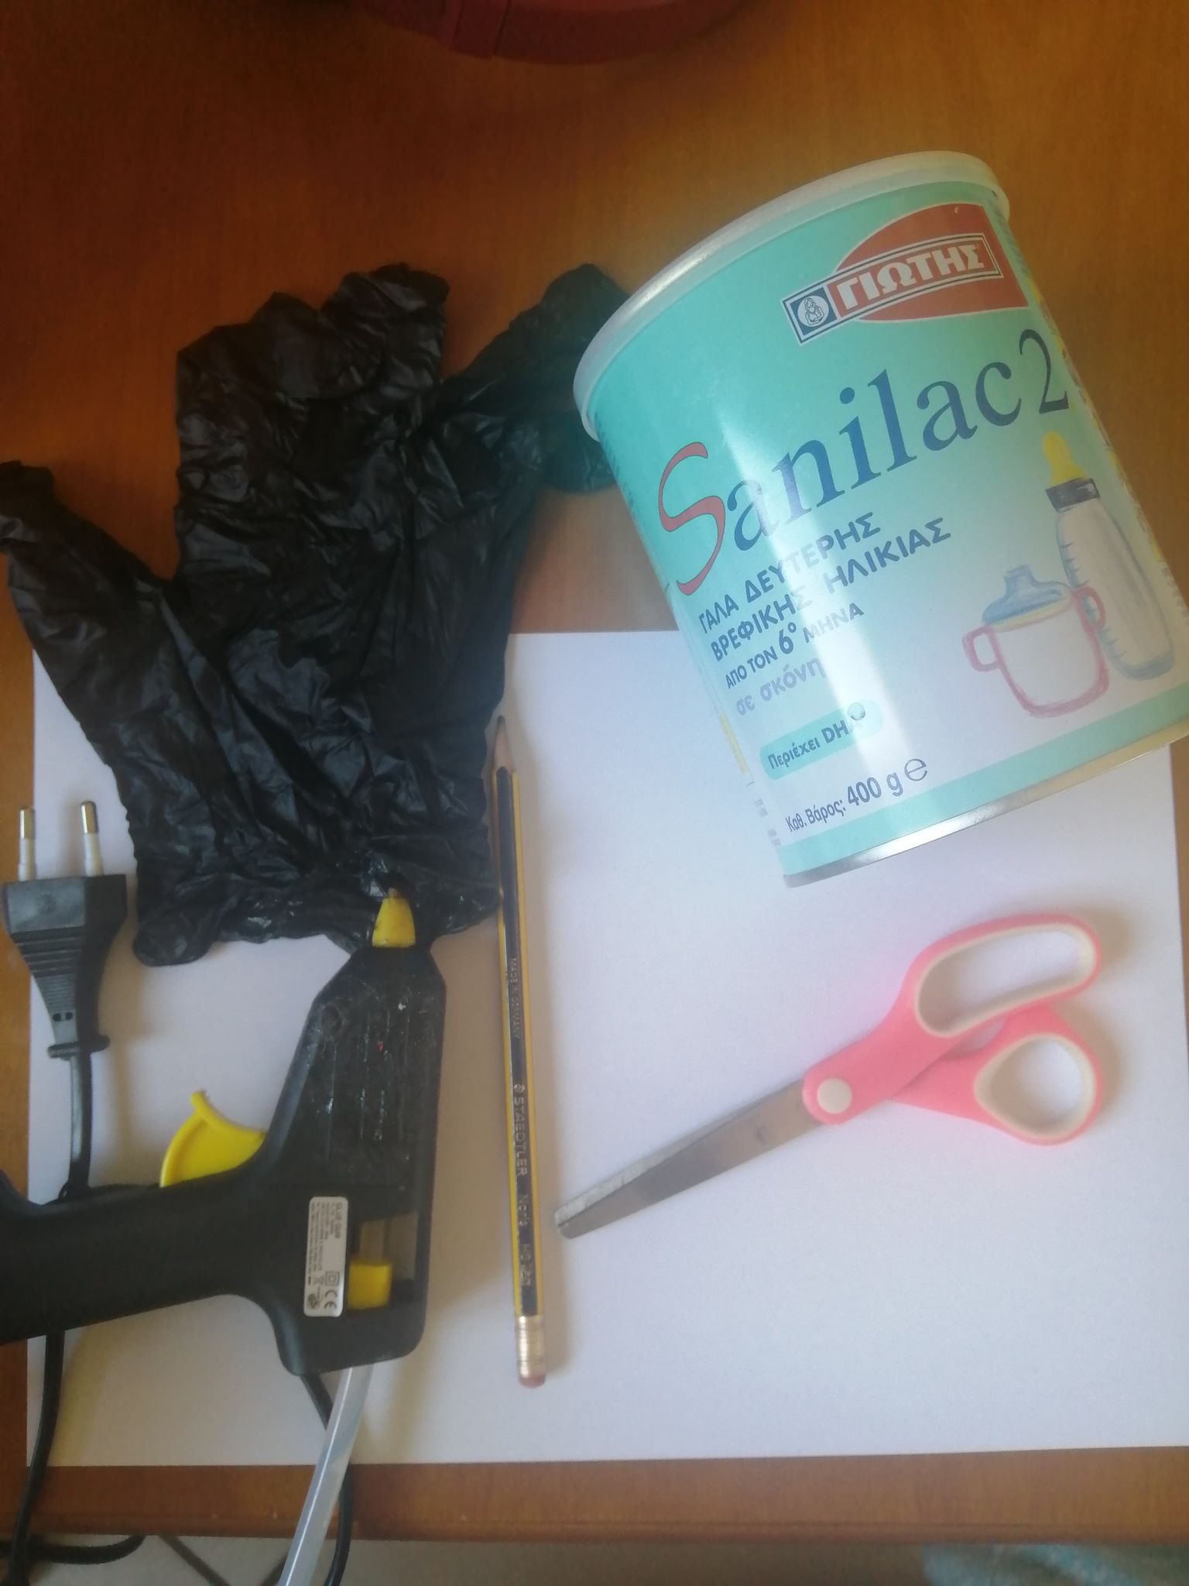Glove or balloon

Form and cut the paper according to our can

Paint and write anything 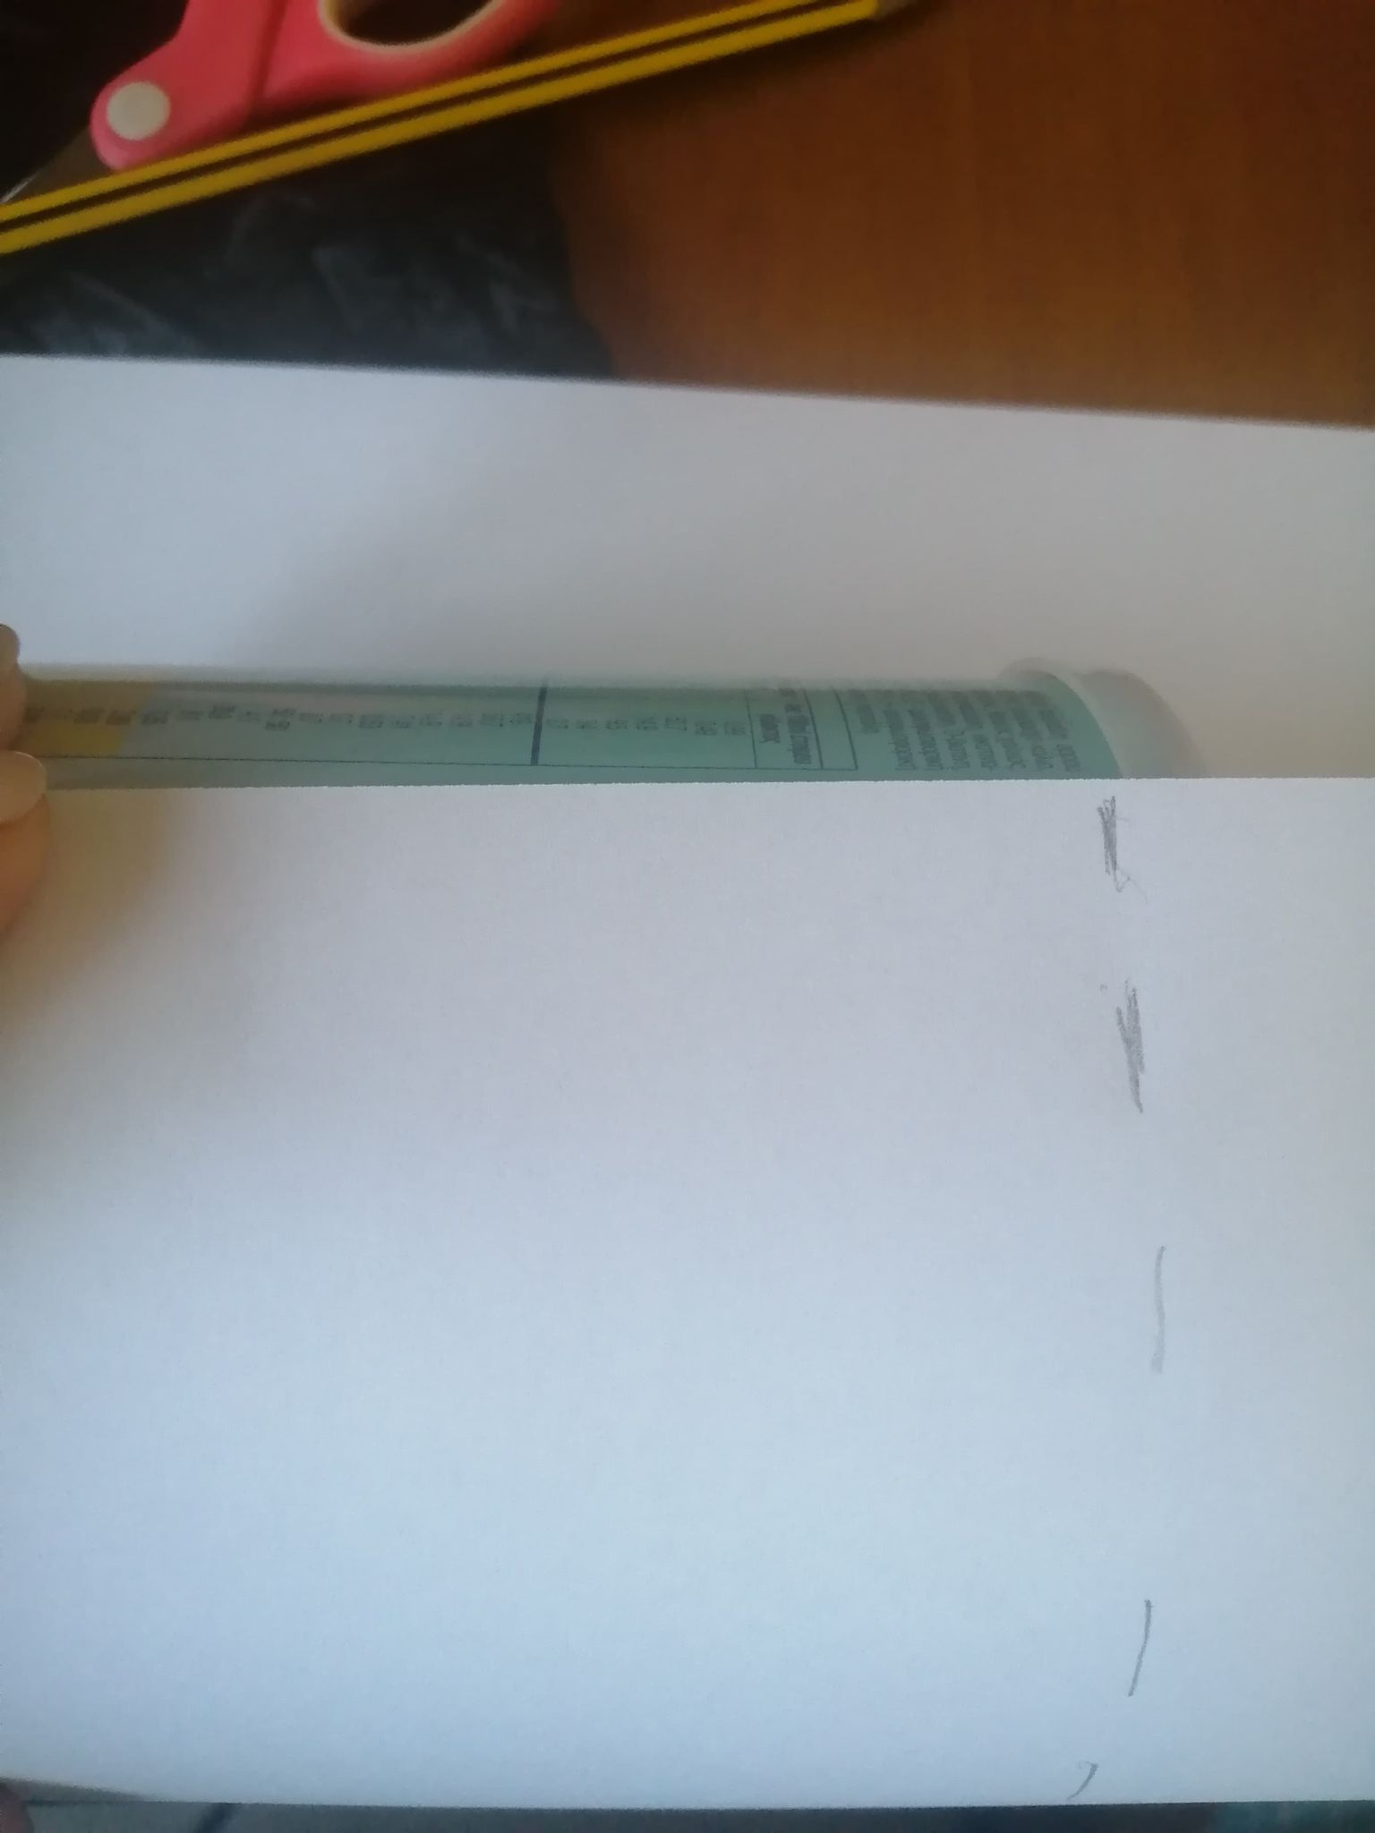that expresses ourselves

Stick the paper on our can

Place the balloon or glove on the empty side of the can

Stretch as much as you can and if necessary we fasten with glue or the rubber band

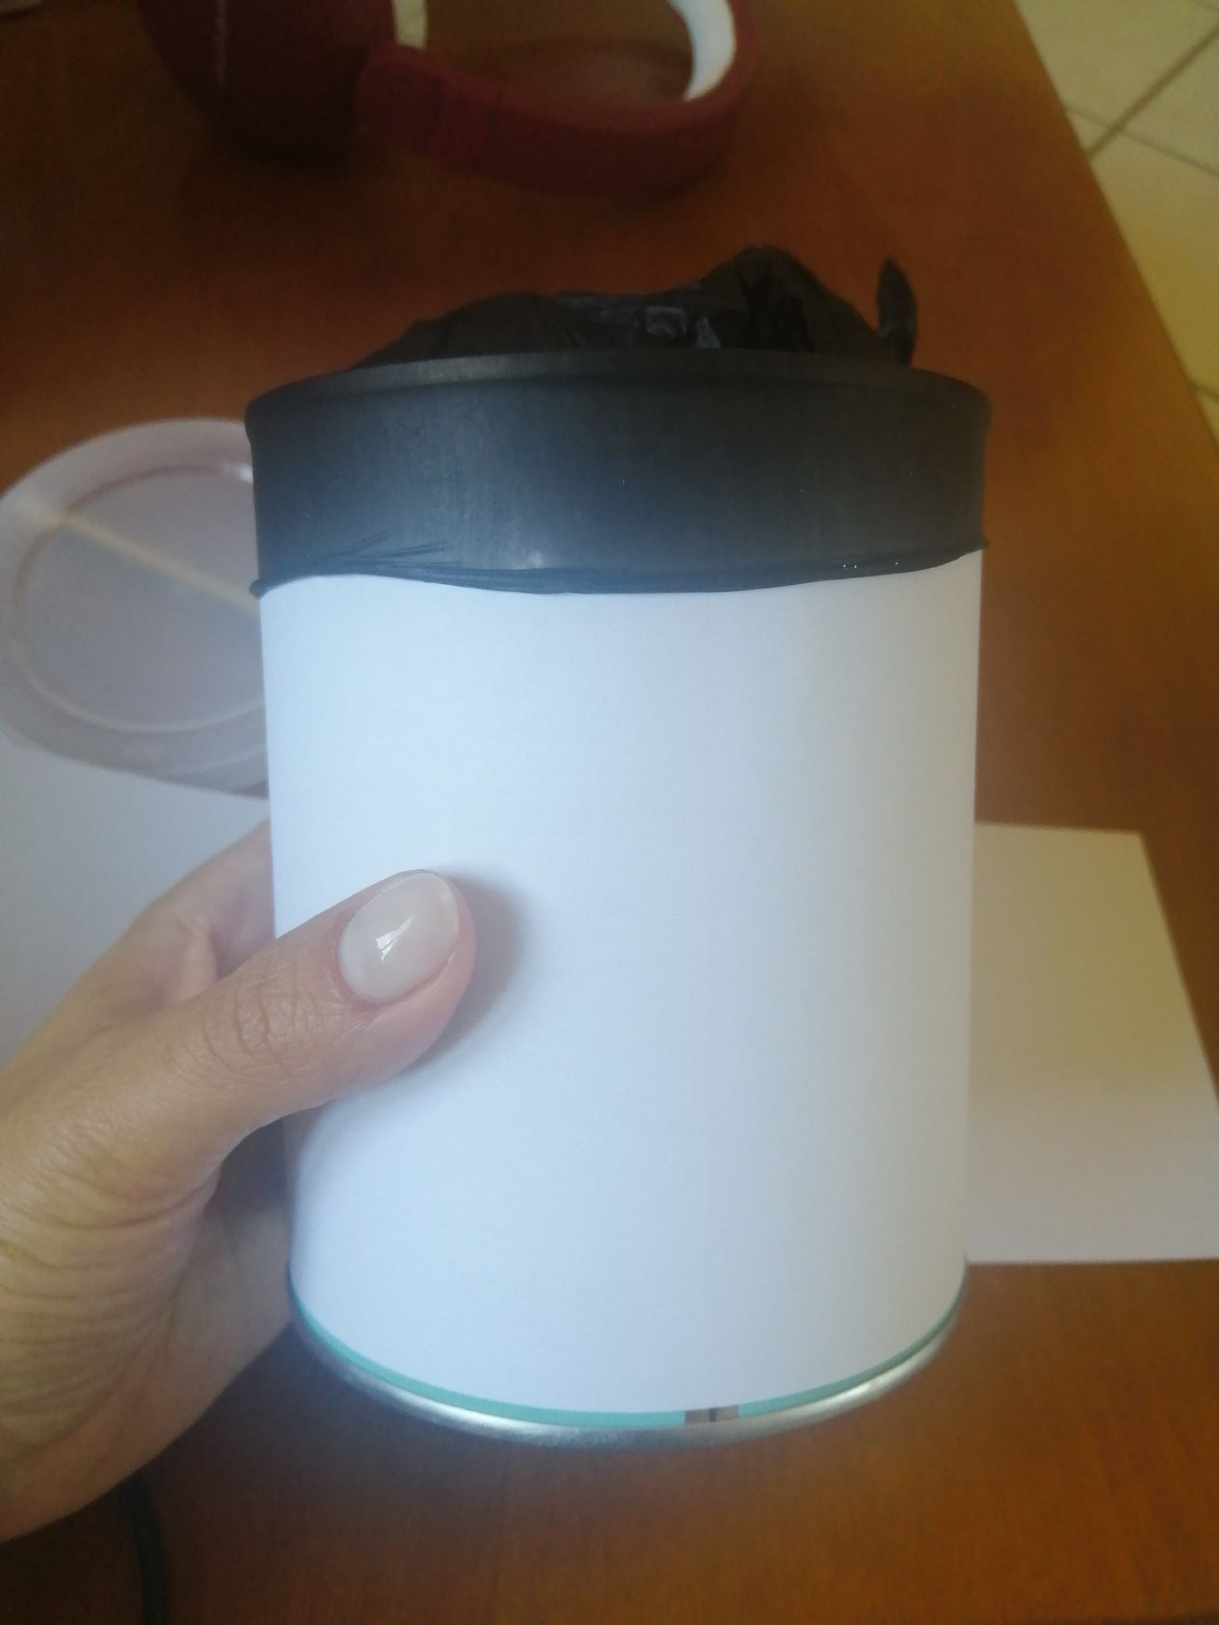

The drums are ready!

We can play our drum with our hand, pinching it or with a pencil

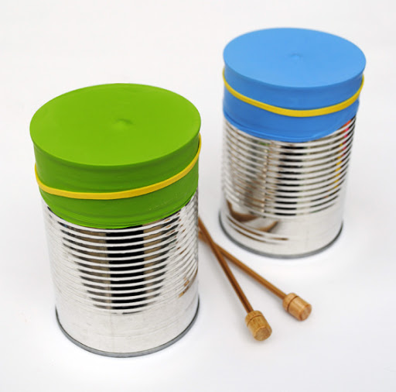  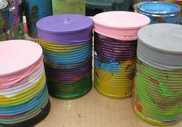

Making a musical instrument

Maracas!!!

**Materials for the musical instrument**

* Roll of toilet paper
* Scissors
* Piece of paper
* Glue or rubber bands
* Pencil
* Rice or legume

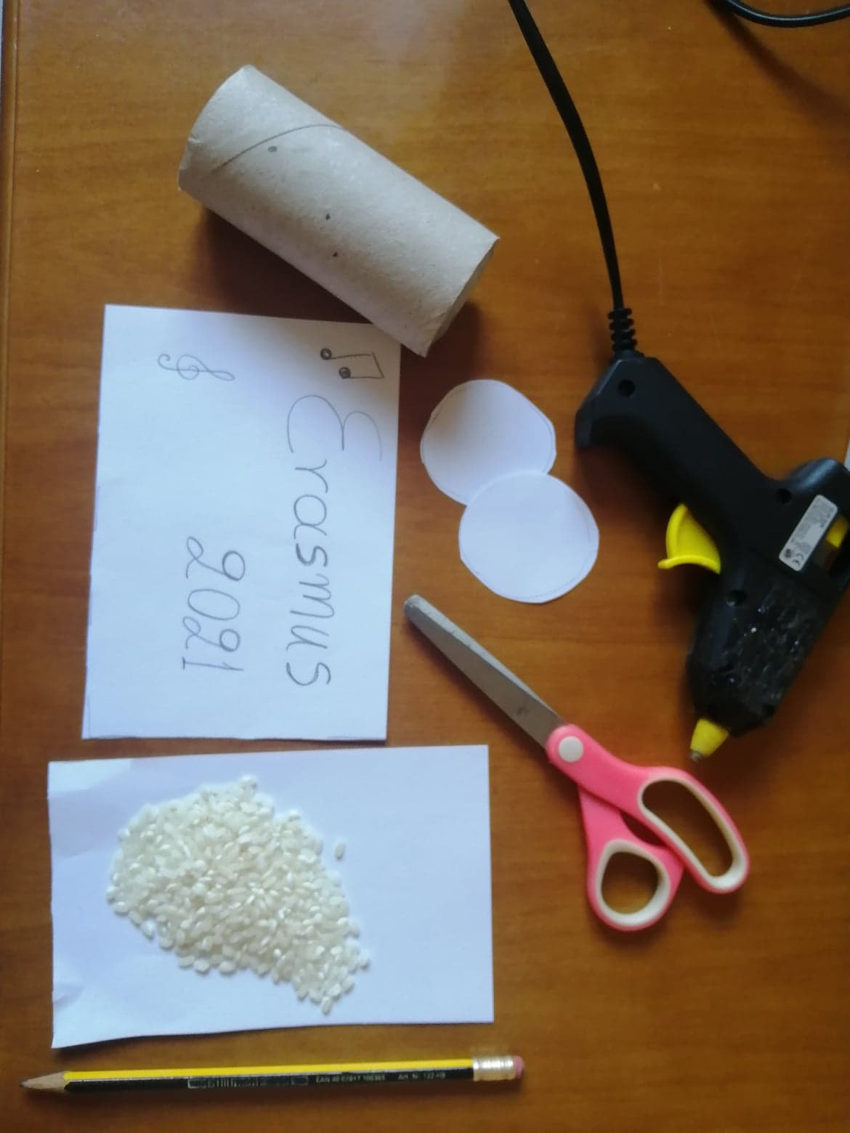

Draw and cut 2 circles and paint the 2 edges of the paper

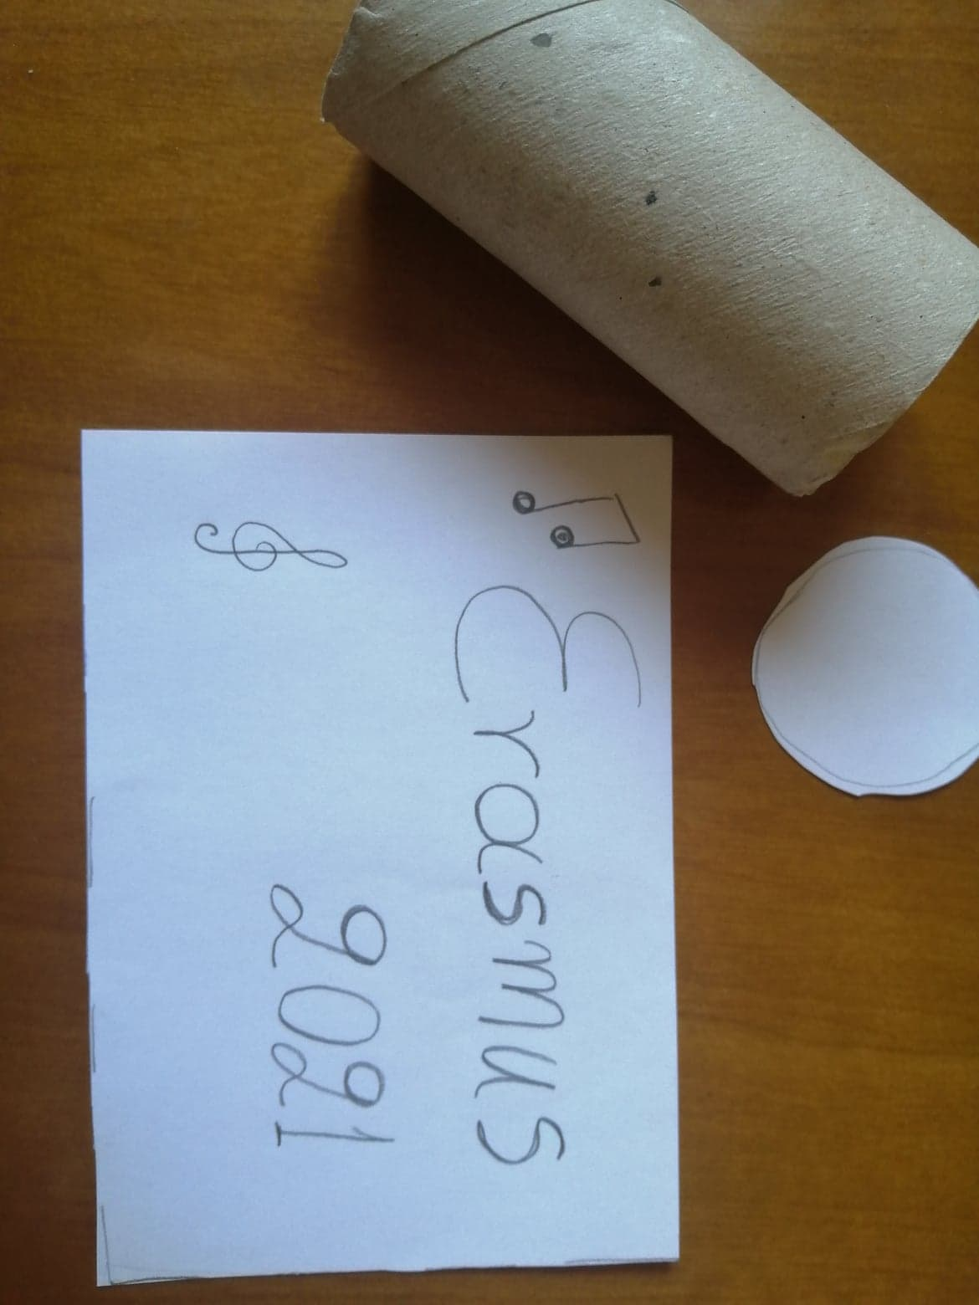If your glue is not strong, cut a square and fix it with rubber bands

Measure and cut paper to wrap our roll

Paint or write anything you want

Stick a circle on one side

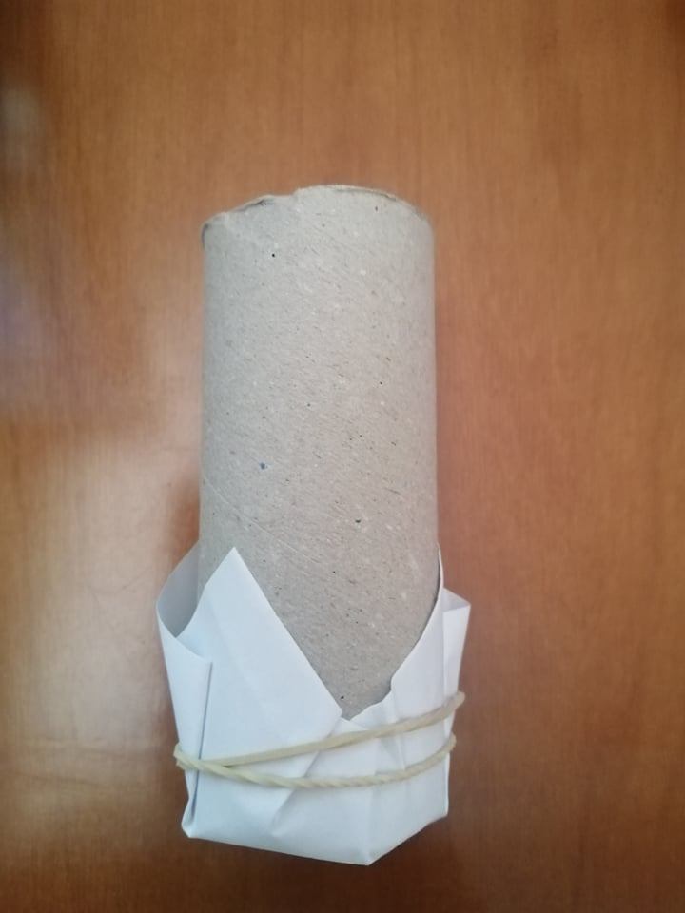After fixing one side, fill the inside with rice

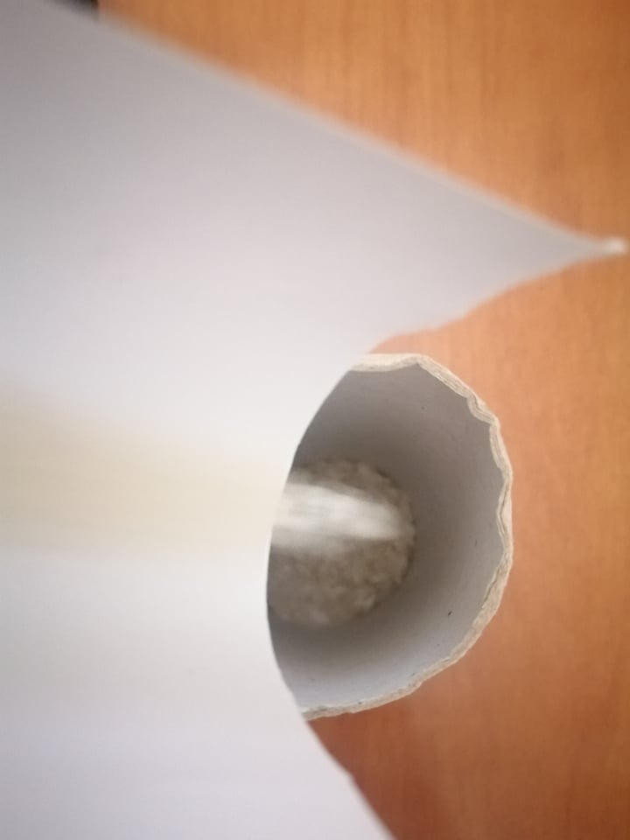

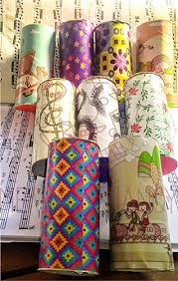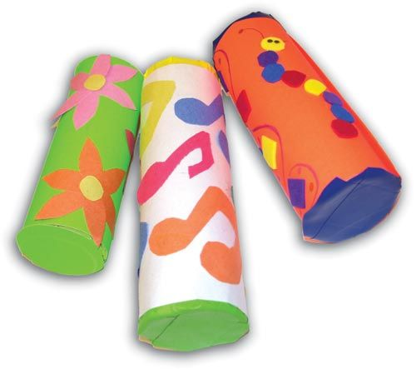Then we glue or fix the other side

