THE 7 MONSTERS OF POLLUTION.

AGAINST THE FEARLESS E-TWINNING PARTNERS

INTRODUCTION

Once upon a time, many many years ago, when people stopped living in caves and forests, and began to cultivate the land, to create culture and build cities to live, the twelve gods of Olympus decided to help them, so they created the seven giants of culture, to look after people, to progress technologically, to cure diseases, to live in peace, to work the land, to take care of the animals, to control the environment and to live harmoniously and happily in their cities.

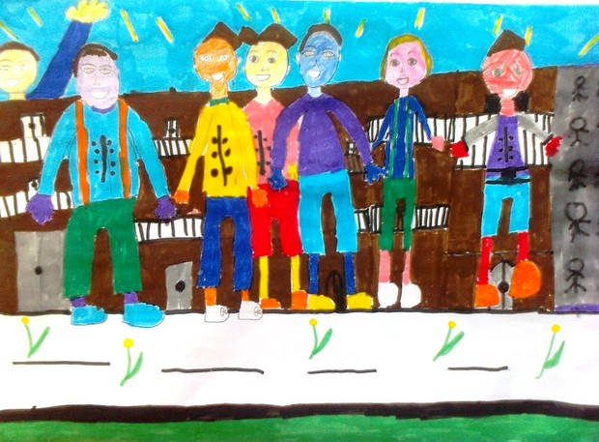

The centuries passed and gradually people, not all but some of them, forgot about the gifts of the gods and the gods themselves (who lived isolated in their palace on Olympus and later left frustrated and to live far away), while they turned the seven giants of culture to their servants and exploited them, but not to make their lives more beautiful, but to gain: wealth, power, authority, control over the environment. They made deadly weapons and constantly made terrible wars, they built countless factories that polluted air and water, made earth dirty with trash and seas with sewage, brought sickness, swept animals, made their cities ugly and full of problems (poverty, racism, traffic congestion, garbage, social conflicts, exploitation, stress, polluted air, terrorism, homeless, refugees, etc.), so it is neither easy nor beautiful to live in them.

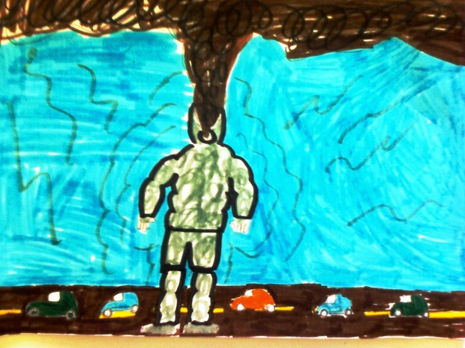

But this eventually turned against them, because the seven giants of culture transformed over time into seven monsters of the pollution, which became uncontrollable and tortured all people, not just those who created them. They occupied the abandoned Olympus and lived there: the Waterdestroyer (which pollutes the seas, lakes and rivers and eliminates water), the Foresterminator (burning forests or cutting their trees to grow cities), the Airpoisoner (contaminating the air with exhaust), the Ice-Ozone-hole (which damage the ozone and causes global warming and melting ice), the Animalkiller (threatening all animals with extinction), the Warmonger (causing wars to destroy people) and the Wealthdisordercity (which for profit destroys life in cities eliminating parks, causing noise, fights, hatred, exploitation, trash, pollution, stress). Their goal has become to destroy humanity and to subdue the earth.

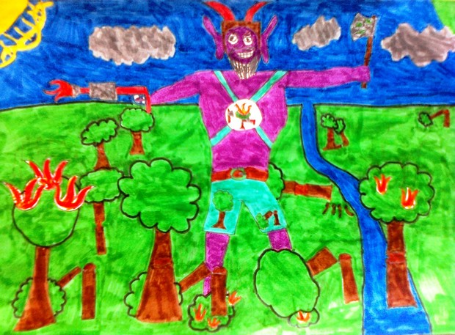

CHAPTER 1

In Thessaloniki, a city in northern Greece, the children in the neighborhood of the 23rd Primary School of the city lived happily in their neighborhood.

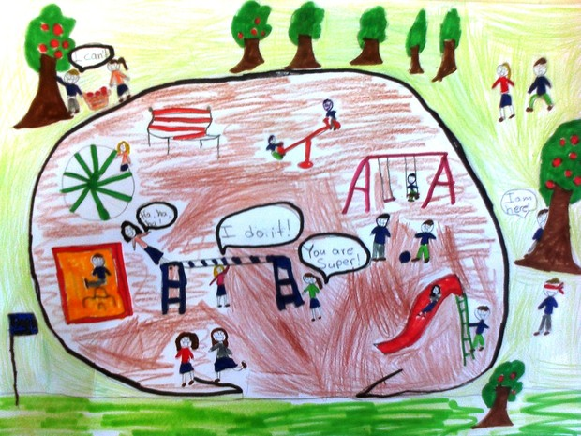

But slowly began to appear many problems around them, which made their lives every day and more bad. The streets were filled with cars that were running too much, making terrible noise, and filling the air with exhaust. The roads themselves were diminished, as are the sidewalks, while the playgrounds were lost, and in their place appeared more and more high-rise buildings. Factories infected air more. The adjacent forest threatened twice burned, while some people managed to illegally cut all the trees from a piece of it and build houses. The streets were filled with trash which smelled badly, and so the stream coming down from the mountain and went a little further than their school. Unemployment fell in the city and many parents of the children were unhappy. People began to be angry and was always ready to quarrel with each other.

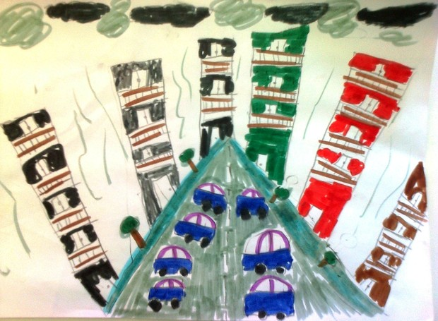

Children did not understand what caused all this. Until one day they went with their teacher an excursion to nearby forest to see up close the trees and the birds there, and they discovered there something terrible.

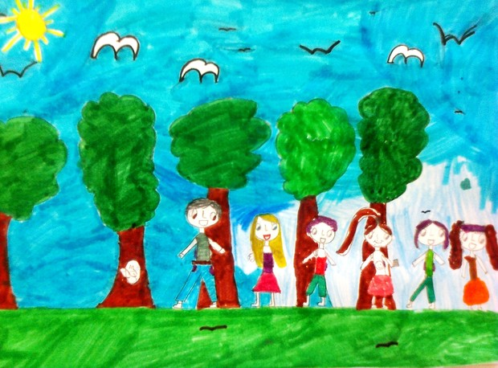

As they played, they noticed a cave that was not previously there. This surprised them. Some of them, pushed by curiosity, went inside. What they saw feared them to death.

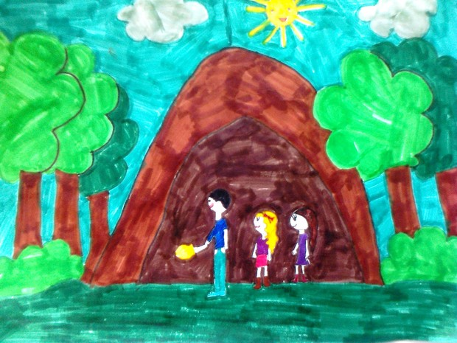

Inside the cave there was a terrible monster. It was tall as a large building, had four huge arms and two legs that reminded smokestacks of factories, wore shoes with wheels as big as cars. Its body resembled building. Its face was ugly, its nose reminded tree, its eyes were red and sunken, like potholes. On its head wore a huge hat for trash. From his mouth came smoke. He spoke only screaming angrily, dining them. In its hand was holding a huge cage in which there were people and animals. When it saw the children, he began chasing them. They came out of the cave quickly squeaking panicky. Everyone began to run toward the adjacent street, which was full of cars. The monster chased them to the edge of the forest. It caught most of the children who had entered the cave and a few more. After that it returned to its cave.

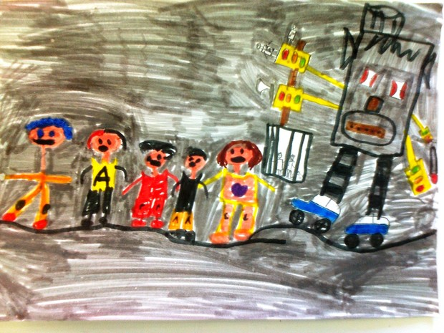

Children, after a while, regained their courage and returned carefully to the cave to find their friends. But the cave wasn’t now visible, and it surprised them. They understood that the monster could hide this way. Who knows how long he lived there without anyone notice it?

They returned into their school. After discussing what to do, they decided to go to mister Sofopoulos, a great scientist who lived in their neighborhood and had visited several times their school. He told them that he had found the monster and had understood what was it by reading some ancient books he found by chance in his library. He even said that he had found a way to make it normal again, if someone gave him a medicine that he had made, which would pull out of it all the malice that had gathered in the years that people tortured it. But who would be able to give him the medicine?

Then suddenly appeared out of nowhere someone whom they knew only from paintings on ancient vases: the god Hermes. He wore a strange hat, scepter, and had wings on his sandals with which he was flying. He explained them about the seven giants of culture, their transformation and the disappearance of the Olympian gods. He said that the Earth is threatened with destruction, and if they want to save it, they must act immediately. The monsters must once again become good giants. They need to find them one by one and change them. He and the other gods were willing to help.

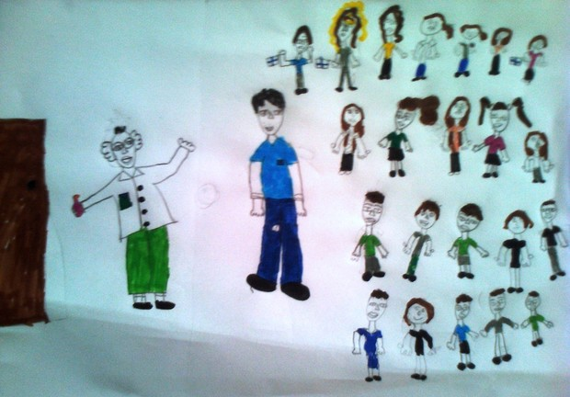

While they were talking, they heard terrible commotion outside. The monster, the Wealthdisordercity, had appeared in the streets. It ate trees and animals, imprisoned people, kicked cars and buses, flattening homes, scattering garbage, bellowed horribly and were making incredible amounts of smoke from its mouth, nose and ears. Children, Mercury and mister Sofopoulos came boldly out. The children drew its attention singing a song about nature. Just came near Hermes transformed into an ice cream seller, flied up to his head and offered him a huge ice cream, in which the scientist had put his medicine. Just when the monster ate it, it stopped the devastation and began to change.

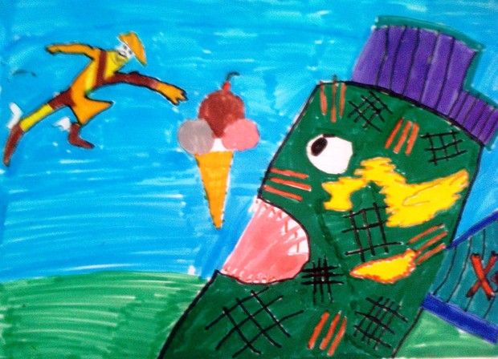

Soon it had its normal form, the good giant with the name Cityhappiness. He told the children the story of his change, how unhappy the people made him. He asked them to watch out their planet and their cities. He told them where lived the other six monsters and urged them to tell their friends to those areas that they have to deal with them and transform them into good giants, if they want to save the Earth. Mercury added in this that the other children will get help from the other gods. Then, Cityhapiness went outside and began reforming the city. The giant wanted to make it beautiful for his friends.

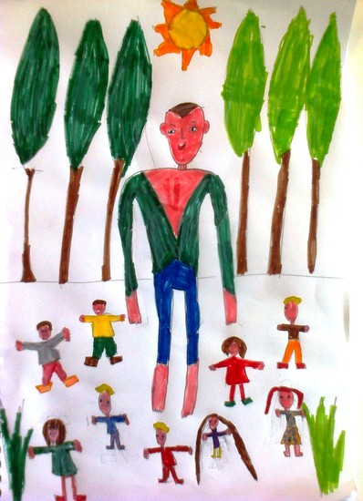

Thus, the children informed their friends in other schools. The Earth has now a new hope that it can be saved.

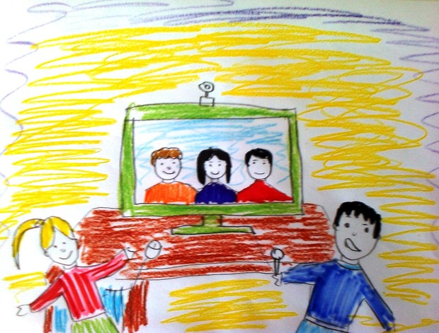

Comments

[**Brigida Clemente**](https://www.facebook.com/brigida.clemente.1) ·

[Διδασκαλία](https://www.facebook.com/pages/%CE%94%CE%B9%CE%B4%CE%B1%CF%83%CE%BA%CE%B1%CE%BB%CE%AF%CE%B1/108464855840777) at [MIUR](https://www.facebook.com/unionerepubblicana/)

dear Greece partners, we like so much your story and hope will do the best for our contribute in the next chapter!