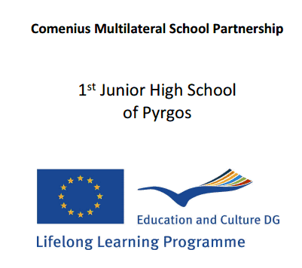

Our trip to Croatia-Bedekovčina (22nd March- 29th March)
We are Dimitris, Aggeliki, Konstantinos, Konstantina-Ioli, Chrysanthi and we represented Greece in our travel to Croatia accompanied by our teachers AsmisLazaros, Koutsoukou Maria, Mposmi Katerina, MichopoulouCharoula, Birba Maria.
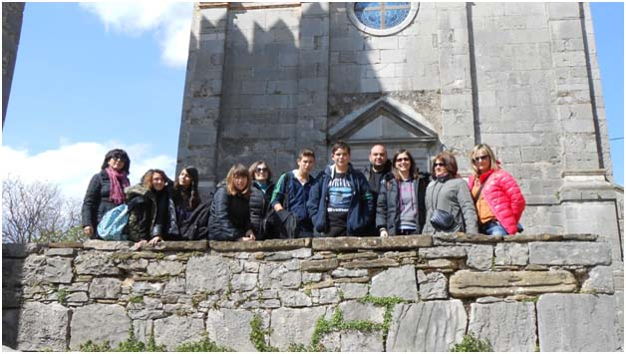

Saturday 22nd March

Our trip began at 4 o’clock at midnight from Pyrgos by coach. From there we departed to our first destination, Belgrade. After many hours’ delay, at 7 o’clock in the afternoon we arrived at the hotel where all of us were going to stay. Later that night we went to take a stroll around the city.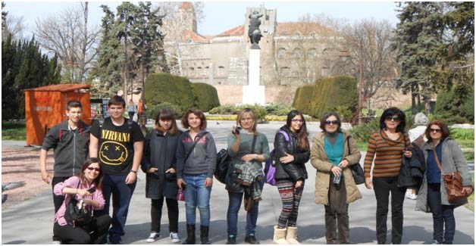
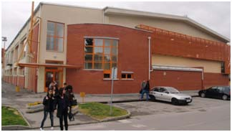

Sunday 23rd March

Next morning we left Belgrade and continued our journey to Croatia. We arrived at 10 o’ clock and met the families who were going to host us. All the families that had welcomed the five of us to stay with them in Croatia were amazing and their hospitality was very generous. We had a little talk with them and then we went to bed because we were tired from our trip.

Monday 24thMarch

Early in the morning we visited Srednjaškolain Bedekovčina.It is a vocational Education and Training School and it consists of three buildings, practice workshops, a greenhouse, a school garden, a sports hall (the largest in the country) and a pupils’ dormitory. Three are the fields of study: Agriculture, Civil Engineering and Medicine.

There, the program coordinators along with some other teachers and the school principal welcomed us with a very interesting presentation of the school and the Zagorje County whereBedekovčina is located. Immediately afterwards, we were led to a large table with many desserts and soft drinks, something very noble! Then we wereshown aroundthe classrooms and the different departments of the school. The mosaic floors, the colorful walls and the magnificent structures that were made by the students werereally amazing. The most interesting part of our visit was the fact that we attended various classes such as pottery, wall painting, medicine, physiotherapy and that was a totally new experience for us.Afterwards, we visited the dormitory. It is for those students who live far away and cannot have transportation for school every day.

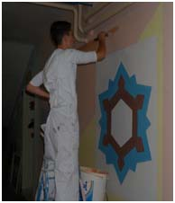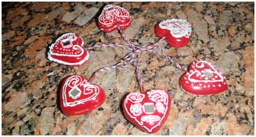

We loved the school and we believe that the children who attend it are very lucky! We would also love to be studentsthere. After that we went to a square named Marija Bistrica where Marian sanctuary is located and we watched how licitar hearts are made.Licitar hearts are colourfully decorated biscuits
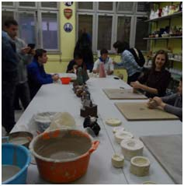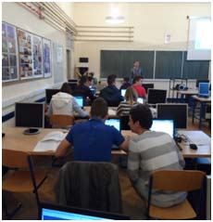made from sweet honey dough and are the traditional ornamental gifts in Croatia. They are also used to decorate Christmas trees. Really impressive! Later that day a European market was held by all partner schools and we sold many of our local products. Then each school presented a theatrical performance. That is how that night ended.
Tuesday 25th March
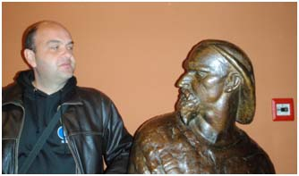
On Tuesday we went on a tour in the capital of Croatia, Zagreb.We visited both the upper and lower part of it. Two of our stops were at the wonderful Cathedral and the Museum of Broken Relationships. The Cathedral which is dedicated to the Assumption of Mary is the largest building in Croatia and its sharp towers can be seen from nearly everywhere in the city.
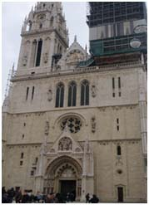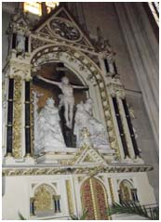

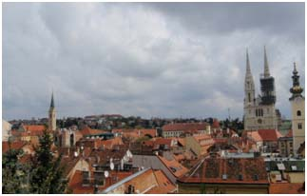
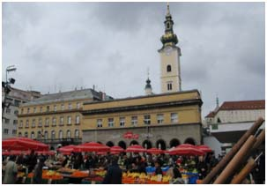

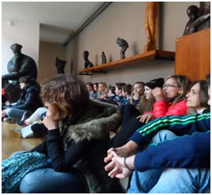The Museum of Broken Relationships surprised us a lot and perhaps there’s such a museum nowhere else. The exhibits were reminders of break-ups and each of them had its ownreal sad or… funny story. Another sight worth mentioning is the AtelierMeštrović.The atelier is an authentic recreation of what was once the home and studio of the world-famous Croatian sculptor Ivan Meštrović. We had the opportunity to admire someof his most significant works inside and outside the building.After that we had free time for three hours to make the most of our visit!We had lunch at a nice pizzeria and went back home to spend the afternoon with the family.
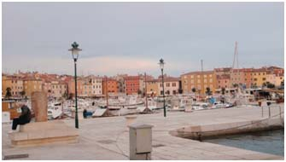

Wednesday 26th March
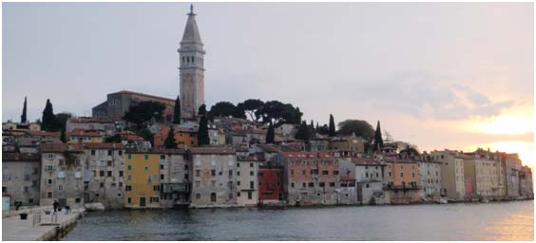

That day we all left from the place we lived (Bedekovcina, Zabok, Oroslavje) and wewent sightseeing in the towns of Istrian Legends in the Istria Peninsula. We visited Hum, Roc, Motovun and Porec, which were all really fascinating.At three o'clock we had lunch and then we visited Rovinj and Pula. No doubt, the splendid harbor with the colourful houses in Rovinj and the Roman amphitheatre in Pula cannot be forgotten. Words cannot describe the beauty we had the privilege to admire during our visit.

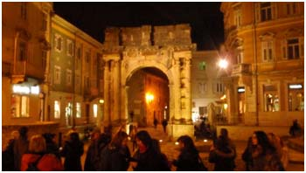

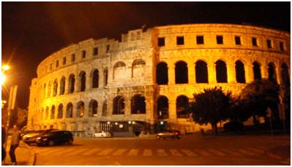

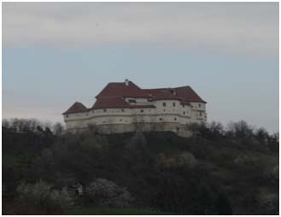

Thursday 27th March
At 8 o’ clock we left Bedekovcina and went to the Krapina Neanderthal Museum. The museum is located at a site where fossils belonging to Neanderthals were discovered. What is worth mentioning is the representation of the evolution of life on the planet. From the early forms of life, bacteria, dinosaurs, the early anthropoids, Homo Neanderthalensis to ...us, Homo Sapiens-Sapiens.After that we visitedVeliki Tabor Castle where we were told the legend of Veronika of Desinić. The owner of the castle, who was a count, showed nomercy for Veronica, a poor girl when his son fell in love
with her. She was imprisoned for witchcraft andthen she was drowned.
Also, that day we went to Kumrovec village which is the birthplace of Tito, the president of the former Yugoslavia. Today the major attraction of Kumrovec is the Ethnological Museum StaroSelo (Old Village) with very well preserved village houses from 19th and 20th century. There we made flowers from crepe paper. At 3 o’ clock we had lunch and we listened to the Croatian anthem. Moreover, we said our last goodbyes because it was the last day in Croatia. When we returned home we had a free afternoon with the families and our teachers had their last meeting.
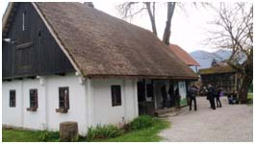
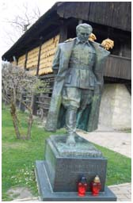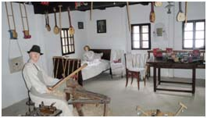

Friday 28th March
So, on Friday we started our trip back to Greeceat about 5 pm. We had a long and tiring journey ahead of us but our enthusiasm for what we had experienced the past few days made up for that tiredness. We will try to keep in touch with our new friends from Norway, Croatia, Italy and Romania as often as we can. We hope that one day we will all meet again and have a fantastic time as we did in Croatia. We are very lucky we visited you, Croatia!
