~PROTECT THE ENVIRONMENT AND THEN
IT WILL PROTECT US TOO~
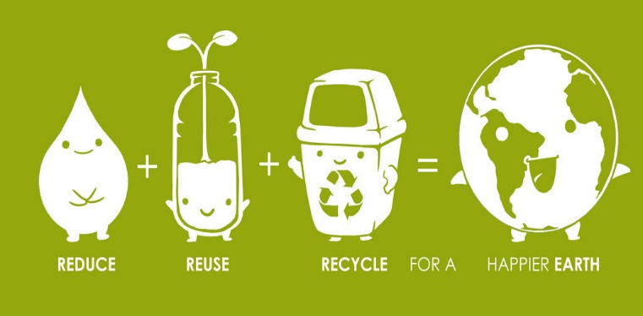
Αυτή η φωτογραφία από Άγνωστος συντάκτης με άδεια χρήσης CC BY-NC-ND
Have you ever heard of these Rs?
Reduce
Reuse
Recycle

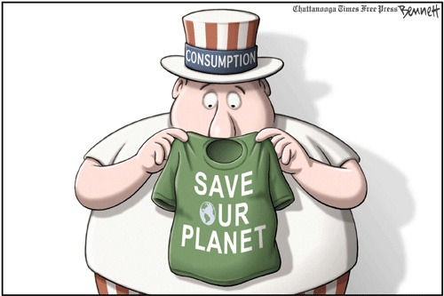
Αυτή η φωτογραφία από Άγνωστος συντάκτης με άδεια χρήσης CC BY-SA-NC

~The poetry of the earth is never dead~

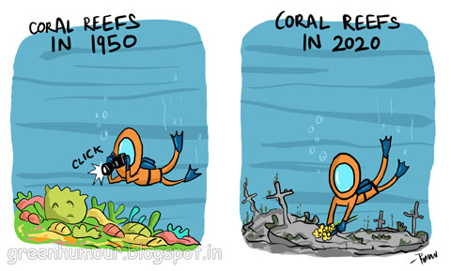
Αυτή η φωτογραφία από Άγνωστος συντάκτης με άδεια χρήσης CC BY-NC-ND
I don’t want to protect the environment, I want to create a word where the environment doesn’t need protecting.

LET’S ALL GO GREEN!

