NAME – SURNAME: ALEXANDER THE GREAT
BIRTHYEAR:356 BC

DEATH YEAR:323 BC

NATIONALITY: GREEK

CATEGORY: GREEK EMPIRER

SHORT LIFE STORY: Alexander III of Macedon commonly known as Alexander the Great was a king of the ancient Greek kingdom of Macedon and a member of the Argead dynasty. He was born in Pella in 356 BC and succeeded his father Philip II to the throne at the age of 20. Hıs mother wa Olimpiada. He spent most of his ruling years on an unprecedented military campaign through Asia and northeast Africa, and he created one of the largest empires of the ancient world by the age of thirty, stretching from Greece to northwestern India He was undefeated in battle and is widely considered one of history's most successful military commanders.
During his youth, Alexander was tutored by Aristotle until age 16. After Philip's assassination in 336BC, he succeeded his father to the throne and inherited a strong kingdom and an experienced army. Alexander was awarded the generalship of Greece and used this authority to launch his father's pan-Hellenic project to lead the Greeks in the conquest of Persia. In 334 BC, he invaded the Achaemenid Empire (Persian Empire) and began a series of campaigns that lasted 10 years. His empire stretched from the Adriatic Sea to the Indus River. He died at the age of 33 after ten days of high fever in 13 June of 323 BC before completing his dream to . He married to Roxane who gave birth to his son Alexander IV two months after his death. His son was murdered in the age of 12 and never became king of Macedonia.
Until today there many scenarios about the place that he was borried but his body has not yet is found.

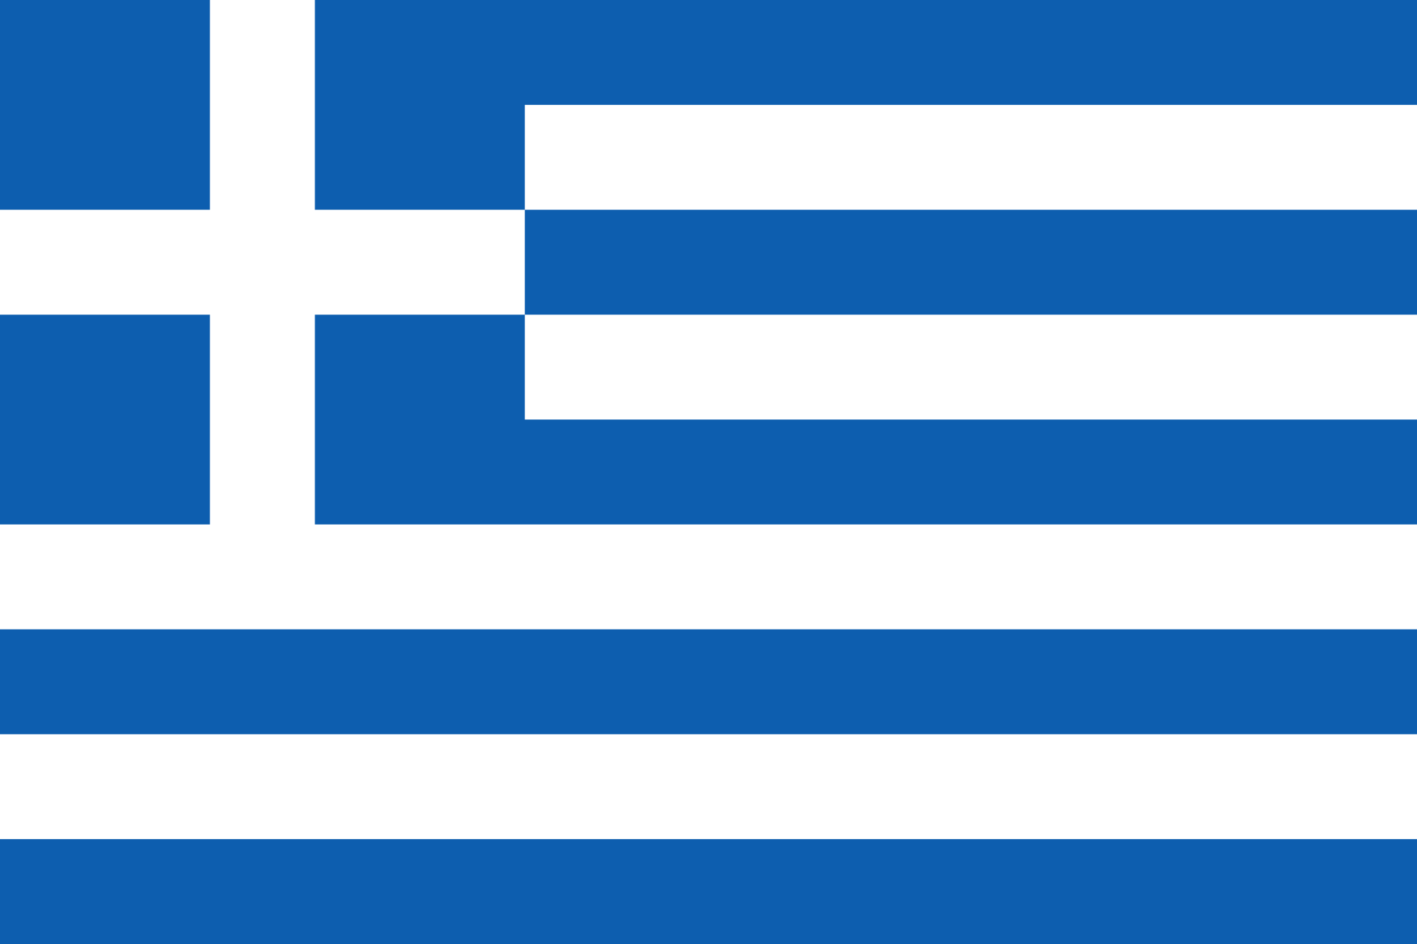FLAG OF HIM OR HER COUNTRY


