**Φύλλα εργασίας**

**The Diary of a Wimpy Kid: Greg’s Mischief! (2)**

**Δραστηριότητα 1: Να επισκεφτείς τα Πολυμέσα της ηλεκτρονικής τάξης (https://eclass02.sch.gr/modules/video/?course=9220341130) και να κάνεις λήψη της ψηφιακής αφήγησης The Diary of a Wimpy Kid.**

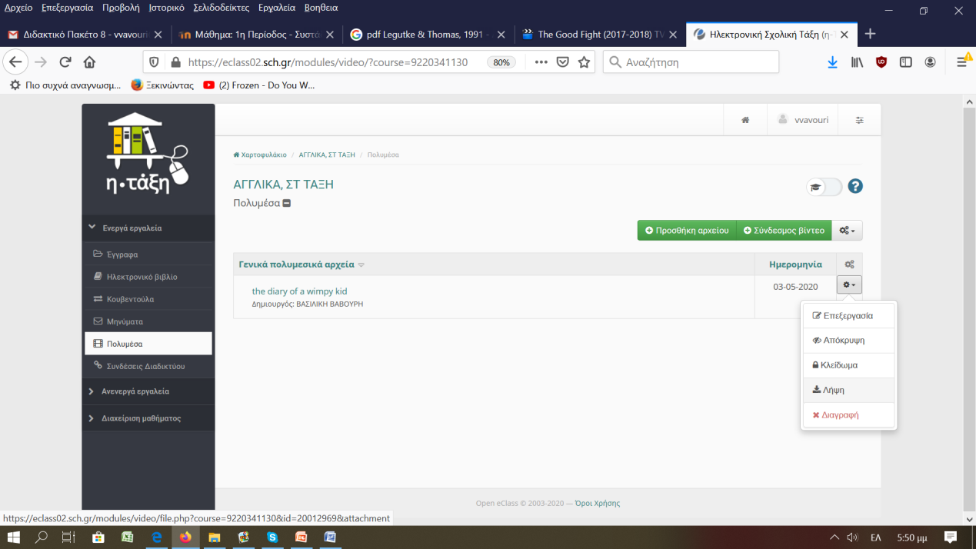

**Στη συνέχεια να παρακολουθήσεις την ψηφιακή αφήγηση με το ζαβολιάρη πρωταγωνιστή και να ολοκληρώσεις τις δραστηριότητες!**

**Θυμήσου!**

|  |  |
| --- | --- |
|  | Teachers Resources  **You can know a lot about a text just by looking at the pictures...**  [**https://www.clipart.email/download/2857210.html**](https://www.clipart.email/download/2857210.html) |
| Wimpy Kid: Double Down Global Tour  **Don’t get stuck on words you don’t know, if you can understand the meaning of the rest of the text!!!!**  <https://www.clipart.email/download/2857209.html> |  |

**Δραστηριότητα 2: Να απαντήσεις τις παρακάτω ερωτήσεις:**

1. What does Greg look like? What colour are his hair/eyes?
2. Why does Greg get bullied at school?
3. How does Greg feel in a school full of bullies?
4. What does Greg think of his classmates? Why?
5. Why does Greg join the Safety Patrol? What does he like the most about it?

**Δραστηριότητα 3: Να βάλεις τις προτάσεις στη σωστή σειρά!**

|  |  |
| --- | --- |
|  | So, Greg told Rowley what happened but told him not to tell anyone. |
|  | A neighbour, saw the incident but mistook Greg for Rowley. |
|  | Mrs Heffley advised Greg to do the right thing. |
|  | Mr Winsky made Rowley apologize to the children and punished him. |
|  | The principal found out the truth and kicked Greg out of the Safety Patrol. |
|  | Mrs. Irvine reported what happened to the principal. |
|  | Greg terrorized the younger children with some worms. |

**Δραστηριότητα 4: Να γράψεις δύο ερωτήσεις που θα ήθελες να κάνεις στο ζαβολιάρη φίλο μας! 1___________________________________________________________________________________________________________________________________  
2__________________________________________________________________________________________________________________________________**

**Τώρα που τελείωσες τις δραστηριότητες, ώρα για παιχνίδι!**

**Να επισκεφτείς την ιστοσελίδα (https://www.jigsawplanet.com/?rc=play&pid=173a37d0212b) και να κάνεις το παζλ από την ομώνυμη ταινία!**