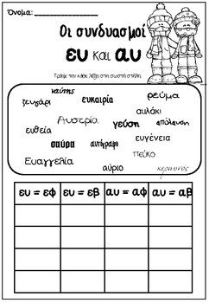
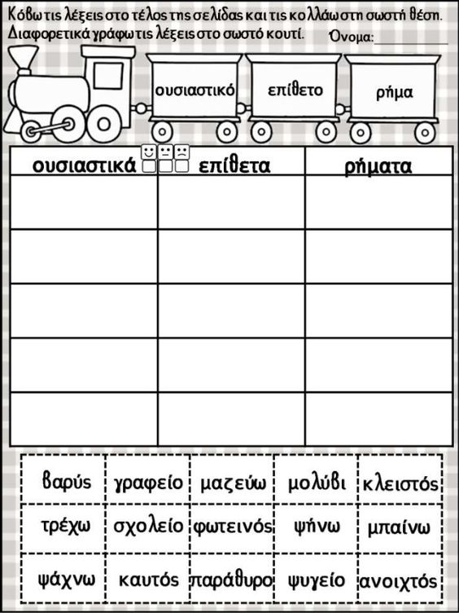
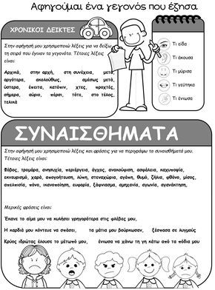
……………………………………………………………………………………………………………………………………………………………………………………………………………………………………………………………………………………………………………………………………………………………………………………………………………………………………………………………………………………………………………………………………………………………………………………………………………………………………………………………………………………………………………………………………………………………………………………………………………………………………………………………………………………………………………………………………………………………………………………………………………………………………………………………………………………………………………………………………………………………………………………………………………………………………………………………………………………………………………………………………………………………………………………………………………………………………………………………………………………………………………………………………………………………………………………………………………………………………………………………………………………………………………………………………………………………………………………………………………………………………………………………………………………………………………………………………………………………………………………………………………………………………………………………………………………………………………………………………………………………………………………………………………………………………………………………………………………………………………………………………………………………………………………………………………………………………………………………………………………………………………………………………………………………………………………………………………………………………………………………………………………………………………………………………………………………………………………………………………………………………………………………………………………………………………………………………………………………………………………………………………………………………………………………………………………………………………………………………………………………………………………………………….
Καλή επιτυχία!

