Όνομα …………………………………..

1. Παρατηρώ τις εικόνες και κάνω τις πράξεις.

BD6**Τα ζευγαράκια του 6.**

MINTMINTMINTMINTMINT + MINT **5 + 1 = 6**

**MINTMINTMINTMINT** + MINTMINT -----------------------------------

MINTMINTMINT + MINTMINTMINT -----------------------------------

MINTMINT + MINTMINTMINTMINT ------------------------------------

MINT + MINTMINTMINTMINTMINT ------------------------------------

**Υπολογίζω τα αθροίσματα.**

**2 + 4 = …….. 3 + 3 = ……. 4 + 2 = …….**

**1 + 5 = …….. 5 + 1 = ……. 6 + 0 = ……..**

4 5 3 6 2  
+ 2 + 1 + 3 + 0 + 4

…………. ……….. ……….. ……….. ……….

2 + 1 + 3 = …… 2 + 2 + 2 = ……. 1 + 4 + 1 = ………

3 + 1 + 2 = …… 4 + 2 + 0 = …… 5 + 1 + 0 = ………

1 + 1 + 2 + 2 = ….. 2 + 1 + 3 + 0 = …… 2 + 1 + 1 + 2 = …….

Συμπληρώνω τον αριθμό που λείπει για να ισχύουν οι ισότητες.

3 + ……. = 6 2 + …… = 6 ……. + 1 = 6 ……. + 3 = 6

1 + ….. + 2 = 6 2 + 3 + ….. = 6 4 + 1 + …… = 6 5 + 1 + …… = 6

2 + 1 +…… + 2 = 6 4 + 1 + …… + 1 = 6 1 + 1 + 2 + ……= 6

**Τα ζευγαράκια του 7.**

**BD7**

**APPLE3APPLE3APPLE3APPLE3APPLE3APPLE3 + APPLE3 6 + 1 = 7**

**APPLE3APPLE3APPLE3APPLE3APPLE3 + APPLE3APPLE3** --------------------------------

**APPLE3APPLE3APPLE3APPLE3 + APPLE3APPLE3APPLE3** ---------------------------------

**APPLE3APPLE3APPLE3 + APPLE3APPLE3APPLE3APPLE3** ---------------------------------

**APPLE3APPLE3 + APPLE3APPLE3APPLE3APPLE3APPLE3** ---------------------------------

**APPLE3 + APPLE3APPLE3APPLE3APPLE3APPLE3APPLE3** ----------------------------------

Μοιράζω τα μήλα στα καλάθια.

APPLE3 APPLE3 APPLE3 APPLE3 APPLE3 APPLE3 APPLE3

[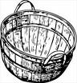](http://images.google.gr/imgres?imgurl=http://www.freeclipartnow.com/d/10277-2/bushel-picking-basket.jpg&imgrefurl=http://www.freeclipartnow.com/construction/tools/gardening/&usg=__uKNJUhNxOgWlCeKg1RrfemvWAcI=&h=200&w=184&sz=14&hl=el&start=46&um=1&tbnid=K6NZjqTtI7_0fM:&tbnh=104&tbnw=96&prev=/images?q=free+basket+cliparts&start=40&ndsp=20&um=1&hl=el&sa=N) [](http://images.google.gr/imgres?imgurl=http://www.freeclipartnow.com/d/10277-2/bushel-picking-basket.jpg&imgrefurl=http://www.freeclipartnow.com/construction/tools/gardening/&usg=__uKNJUhNxOgWlCeKg1RrfemvWAcI=&h=200&w=184&sz=14&hl=el&start=46&um=1&tbnid=K6NZjqTtI7_0fM:&tbnh=104&tbnw=96&prev=/images?q=free+basket+cliparts&start=40&ndsp=20&um=1&hl=el&sa=N) [](http://images.google.gr/imgres?imgurl=http://www.freeclipartnow.com/d/10277-2/bushel-picking-basket.jpg&imgrefurl=http://www.freeclipartnow.com/construction/tools/gardening/&usg=__uKNJUhNxOgWlCeKg1RrfemvWAcI=&h=200&w=184&sz=14&hl=el&start=46&um=1&tbnid=K6NZjqTtI7_0fM:&tbnh=104&tbnw=96&prev=/images?q=free+basket+cliparts&start=40&ndsp=20&um=1&hl=el&sa=N) [](http://images.google.gr/imgres?imgurl=http://www.freeclipartnow.com/d/10277-2/bushel-picking-basket.jpg&imgrefurl=http://www.freeclipartnow.com/construction/tools/gardening/&usg=__uKNJUhNxOgWlCeKg1RrfemvWAcI=&h=200&w=184&sz=14&hl=el&start=46&um=1&tbnid=K6NZjqTtI7_0fM:&tbnh=104&tbnw=96&prev=/images?q=free+basket+cliparts&start=40&ndsp=20&um=1&hl=el&sa=N)

[](http://images.google.gr/imgres?imgurl=http://www.freeclipartnow.com/d/10277-2/bushel-picking-basket.jpg&imgrefurl=http://www.freeclipartnow.com/construction/tools/gardening/&usg=__uKNJUhNxOgWlCeKg1RrfemvWAcI=&h=200&w=184&sz=14&hl=el&start=46&um=1&tbnid=K6NZjqTtI7_0fM:&tbnh=104&tbnw=96&prev=/images?q=free+basket+cliparts&start=40&ndsp=20&um=1&hl=el&sa=N) [](http://images.google.gr/imgres?imgurl=http://www.freeclipartnow.com/d/10277-2/bushel-picking-basket.jpg&imgrefurl=http://www.freeclipartnow.com/construction/tools/gardening/&usg=__uKNJUhNxOgWlCeKg1RrfemvWAcI=&h=200&w=184&sz=14&hl=el&start=46&um=1&tbnid=K6NZjqTtI7_0fM:&tbnh=104&tbnw=96&prev=/images?q=free+basket+cliparts&start=40&ndsp=20&um=1&hl=el&sa=N) [](http://images.google.gr/imgres?imgurl=http://www.freeclipartnow.com/d/10277-2/bushel-picking-basket.jpg&imgrefurl=http://www.freeclipartnow.com/construction/tools/gardening/&usg=__uKNJUhNxOgWlCeKg1RrfemvWAcI=&h=200&w=184&sz=14&hl=el&start=46&um=1&tbnid=K6NZjqTtI7_0fM:&tbnh=104&tbnw=96&prev=/images?q=free+basket+cliparts&start=40&ndsp=20&um=1&hl=el&sa=N) [](http://images.google.gr/imgres?imgurl=http://www.freeclipartnow.com/d/10277-2/bushel-picking-basket.jpg&imgrefurl=http://www.freeclipartnow.com/construction/tools/gardening/&usg=__uKNJUhNxOgWlCeKg1RrfemvWAcI=&h=200&w=184&sz=14&hl=el&start=46&um=1&tbnid=K6NZjqTtI7_0fM:&tbnh=104&tbnw=96&prev=/images?q=free+basket+cliparts&start=40&ndsp=20&um=1&hl=el&sa=N)

Υπολογίζω τα αθροίσματα.

6 + 1 = …… 7 + 0 = ……. 2 + 5 = ……. 4 + 3 = …….

1 + 6 = ….. 3 + 4 = …… 5 + 2 = …… 0 + 7 = …….

1 + …… = 7 2 + …… = 7 4 + …… = 7 …… + 5 = 7

……. + 1 = 7 ……. + 3 = 7 0 + ….. = 7 …… + 0 = 7

1 + 2 + ……= 7 2 + 3 + …….= 7 1 + 4 + ……. = 7

3 2 4 …….

+ …… + …… + ……. + 6

7 7 7 7

**Όνομα:……………………………………………………………………..………….**

**Τα ζευγαράκια του 8.**

CARROTCARROTCARROTCARROTCARROTCARROTCARROT + CARROT **7 + 1 = 8**

CARROTCARROTCARROTCARROTCARROTCARROT + CARROT CARROT ……………………………….

CARROTCARROTCARROTCARROTCARROT + CARROTCARROTCARROT ……………………………….

CARROTCARROTCARROTCARROT + CARROTCARROTCARROTCARROT ………………………………..

CARROTCARROTCARROT + CARROTCARROTCARROTCARROTCARROT …………………………………

CARROTCARROT + CARROTCARROTCARROTCARROTCARROTCARROT ……………………………………………….

CARROT + CARROTCARROTCARROTCARROTCARROTCARROTCARROT ………………………………………………

Υπολογίζω τα αθροίσματα.

2 + 6 = ……. 4 + 4 = …… 7 + 1 = ……. 0 + 8 = …….

5 + 3 = ……. 6 + 2 = ……. 1 + 7 = …… 8 + 0 = ……..

2 + 2 + 4 = ……. 3 + 2 + 3 = …… 1 + 4 + 3 = ……..

5 + 1 + 2 = …… 4 + 3 + 1 = …… 1 + 1 + 4 + 2 = …….

Συμπληρώνω τον αριθμό που πρέπει για να ισχύουν οι ισότητες.

6 + …… = 8 5 + ……. = 8 4 + ……. = 8 1 + ……. = 8

……. + 3 = 8 …… + 1 = 8 ……. + 6 = 8 ……. + 2 = 8

1 + 2 + …… = 8 3 + ……. + 3 = 8 4 + ……. + 2 = 8

**Όνομα:………………………………………………………………………..**

BD9**Τα ζευγαράκια του 9.**

BABYDUMBABYDUMBABYDUMBABYDUMBABYDUMBABYDUMBABYDUMBABYDUM + BABYDUM **8 + 1 = 9**

BABYDUMBABYDUMBABYDUMBABYDUMBABYDUMBABYDUMBABYDUM + BABYDUMBABYDUM ……………………….

BABYDUMBABYDUMBABYDUMBABYDUMBABYDUMBABYDUM + BABYDUMBABYDUMBABYDUM ………………………..

BABYDUMBABYDUMBABYDUMBABYDUMBABYDUM + BABYDUMBABYDUMBABYDUMBABYDUM ………………………..

BABYDUMBABYDUMBABYDUMBABYDUM + BABYDUMBABYDUMBABYDUMBABYDUMBABYDUM ………………………..

BABYDUMBABYDUMBABYDUM + BABYDUMBABYDUMBABYDUMBABYDUMBABYDUMBABYDUM ………………………..

BABYDUMBABYDUM + BABYDUMBABYDUMBABYDUMBABYDUMBABYDUMBABYDUMBABYDUM ………………………..

BABYDUM + BABYDUMBABYDUMBABYDUMBABYDUMBABYDUMBABYDUMBABYDUMBABYDUM ………………………..

Υπολογίζω τα αθροίσματα.

4 + 5 = …… 6 + 3 = ……. 8 + 1 = ……. 7 + 2 = ……..

2 + 7 = …… 1 + 8 = ……. 5 + 4 = …… 9 + 0 = ……..

1 + 2 + 6 = …… 5 + 2 + 2 = ……. 4 + 3 + 2 = …….

4 + 4 + 1 = …… 3 + 3 + 3 = ……. 0 + 2 + 7 = …….

Μοιράζω τα στολίδια στα χριστουγεννιάτικα δέντρα.

[](http://images.google.gr/imgres?imgurl=http://www.imageenvision.com/md/stock_photography/round_and_shiny_blue_tree_bauble_ornament_with_a_red_bow.jpg&imgrefurl=http://www.imageenvision.com/stock_clipart/details/0026-0805-0212-3314/round_and_shiny_blue_tree_bauble_ornament_with_a_red_bow&usg=__PxifFPClDXbr6hKN88HvI0hYV7k=&h=450&w=370&sz=37&hl=el&start=1&um=1&tbnid=NFgaYd8w08MjyM:&tbnh=127&tbnw=104&prev=/images?q=free+christmas+balls+cliparts&ndsp=20&um=1&hl=el&sa=N) [](http://images.google.gr/imgres?imgurl=http://www.imageenvision.com/md/stock_photography/round_and_shiny_blue_tree_bauble_ornament_with_a_red_bow.jpg&imgrefurl=http://www.imageenvision.com/stock_clipart/details/0026-0805-0212-3314/round_and_shiny_blue_tree_bauble_ornament_with_a_red_bow&usg=__PxifFPClDXbr6hKN88HvI0hYV7k=&h=450&w=370&sz=37&hl=el&start=1&um=1&tbnid=NFgaYd8w08MjyM:&tbnh=127&tbnw=104&prev=/images?q=free+christmas+balls+cliparts&ndsp=20&um=1&hl=el&sa=N) [](http://images.google.gr/imgres?imgurl=http://www.imageenvision.com/md/stock_photography/round_and_shiny_blue_tree_bauble_ornament_with_a_red_bow.jpg&imgrefurl=http://www.imageenvision.com/stock_clipart/details/0026-0805-0212-3314/round_and_shiny_blue_tree_bauble_ornament_with_a_red_bow&usg=__PxifFPClDXbr6hKN88HvI0hYV7k=&h=450&w=370&sz=37&hl=el&start=1&um=1&tbnid=NFgaYd8w08MjyM:&tbnh=127&tbnw=104&prev=/images?q=free+christmas+balls+cliparts&ndsp=20&um=1&hl=el&sa=N) [](http://images.google.gr/imgres?imgurl=http://www.imageenvision.com/md/stock_photography/round_and_shiny_blue_tree_bauble_ornament_with_a_red_bow.jpg&imgrefurl=http://www.imageenvision.com/stock_clipart/details/0026-0805-0212-3314/round_and_shiny_blue_tree_bauble_ornament_with_a_red_bow&usg=__PxifFPClDXbr6hKN88HvI0hYV7k=&h=450&w=370&sz=37&hl=el&start=1&um=1&tbnid=NFgaYd8w08MjyM:&tbnh=127&tbnw=104&prev=/images?q=free+christmas+balls+cliparts&ndsp=20&um=1&hl=el&sa=N) [](http://images.google.gr/imgres?imgurl=http://www.imageenvision.com/md/stock_photography/round_and_shiny_blue_tree_bauble_ornament_with_a_red_bow.jpg&imgrefurl=http://www.imageenvision.com/stock_clipart/details/0026-0805-0212-3314/round_and_shiny_blue_tree_bauble_ornament_with_a_red_bow&usg=__PxifFPClDXbr6hKN88HvI0hYV7k=&h=450&w=370&sz=37&hl=el&start=1&um=1&tbnid=NFgaYd8w08MjyM:&tbnh=127&tbnw=104&prev=/images?q=free+christmas+balls+cliparts&ndsp=20&um=1&hl=el&sa=N) [](http://images.google.gr/imgres?imgurl=http://www.imageenvision.com/md/stock_photography/round_and_shiny_blue_tree_bauble_ornament_with_a_red_bow.jpg&imgrefurl=http://www.imageenvision.com/stock_clipart/details/0026-0805-0212-3314/round_and_shiny_blue_tree_bauble_ornament_with_a_red_bow&usg=__PxifFPClDXbr6hKN88HvI0hYV7k=&h=450&w=370&sz=37&hl=el&start=1&um=1&tbnid=NFgaYd8w08MjyM:&tbnh=127&tbnw=104&prev=/images?q=free+christmas+balls+cliparts&ndsp=20&um=1&hl=el&sa=N) [](http://images.google.gr/imgres?imgurl=http://www.imageenvision.com/md/stock_photography/round_and_shiny_blue_tree_bauble_ornament_with_a_red_bow.jpg&imgrefurl=http://www.imageenvision.com/stock_clipart/details/0026-0805-0212-3314/round_and_shiny_blue_tree_bauble_ornament_with_a_red_bow&usg=__PxifFPClDXbr6hKN88HvI0hYV7k=&h=450&w=370&sz=37&hl=el&start=1&um=1&tbnid=NFgaYd8w08MjyM:&tbnh=127&tbnw=104&prev=/images?q=free+christmas+balls+cliparts&ndsp=20&um=1&hl=el&sa=N) [](http://images.google.gr/imgres?imgurl=http://www.imageenvision.com/md/stock_photography/round_and_shiny_blue_tree_bauble_ornament_with_a_red_bow.jpg&imgrefurl=http://www.imageenvision.com/stock_clipart/details/0026-0805-0212-3314/round_and_shiny_blue_tree_bauble_ornament_with_a_red_bow&usg=__PxifFPClDXbr6hKN88HvI0hYV7k=&h=450&w=370&sz=37&hl=el&start=1&um=1&tbnid=NFgaYd8w08MjyM:&tbnh=127&tbnw=104&prev=/images?q=free+christmas+balls+cliparts&ndsp=20&um=1&hl=el&sa=N) [](http://images.google.gr/imgres?imgurl=http://www.imageenvision.com/md/stock_photography/round_and_shiny_blue_tree_bauble_ornament_with_a_red_bow.jpg&imgrefurl=http://www.imageenvision.com/stock_clipart/details/0026-0805-0212-3314/round_and_shiny_blue_tree_bauble_ornament_with_a_red_bow&usg=__PxifFPClDXbr6hKN88HvI0hYV7k=&h=450&w=370&sz=37&hl=el&start=1&um=1&tbnid=NFgaYd8w08MjyM:&tbnh=127&tbnw=104&prev=/images?q=free+christmas+balls+cliparts&ndsp=20&um=1&hl=el&sa=N)

[](http://images.google.gr/imgres?imgurl=http://bp0.blogger.com/_JGdUONuSdxc/R2huRssk4iI/AAAAAAAAA1s/lPuU2TM-thU/s320/christmas-tree-clipart-clip-art-christmas-tree-free-christmas-clipart-christmas-tree-image-1med.gif&imgrefurl=http://charlottes4angels.blogspot.com/2007/12/kids-got-mail-from-north-pole.html&usg=__ZoB3vhqU314M3LFkdCoIPAIkod4=&h=236&w=200&sz=3&hl=el&start=47&um=1&tbnid=andbkFzPGTV1HM:&tbnh=109&tbnw=92&prev=/images?q=free+christmas+tree+cliparts&start=40&ndsp=20&um=1&hl=el&sa=N) [](http://images.google.gr/imgres?imgurl=http://bp0.blogger.com/_JGdUONuSdxc/R2huRssk4iI/AAAAAAAAA1s/lPuU2TM-thU/s320/christmas-tree-clipart-clip-art-christmas-tree-free-christmas-clipart-christmas-tree-image-1med.gif&imgrefurl=http://charlottes4angels.blogspot.com/2007/12/kids-got-mail-from-north-pole.html&usg=__ZoB3vhqU314M3LFkdCoIPAIkod4=&h=236&w=200&sz=3&hl=el&start=47&um=1&tbnid=andbkFzPGTV1HM:&tbnh=109&tbnw=92&prev=/images?q=free+christmas+tree+cliparts&start=40&ndsp=20&um=1&hl=el&sa=N) [](http://images.google.gr/imgres?imgurl=http://bp0.blogger.com/_JGdUONuSdxc/R2huRssk4iI/AAAAAAAAA1s/lPuU2TM-thU/s320/christmas-tree-clipart-clip-art-christmas-tree-free-christmas-clipart-christmas-tree-image-1med.gif&imgrefurl=http://charlottes4angels.blogspot.com/2007/12/kids-got-mail-from-north-pole.html&usg=__ZoB3vhqU314M3LFkdCoIPAIkod4=&h=236&w=200&sz=3&hl=el&start=47&um=1&tbnid=andbkFzPGTV1HM:&tbnh=109&tbnw=92&prev=/images?q=free+christmas+tree+cliparts&start=40&ndsp=20&um=1&hl=el&sa=N) [](http://images.google.gr/imgres?imgurl=http://bp0.blogger.com/_JGdUONuSdxc/R2huRssk4iI/AAAAAAAAA1s/lPuU2TM-thU/s320/christmas-tree-clipart-clip-art-christmas-tree-free-christmas-clipart-christmas-tree-image-1med.gif&imgrefurl=http://charlottes4angels.blogspot.com/2007/12/kids-got-mail-from-north-pole.html&usg=__ZoB3vhqU314M3LFkdCoIPAIkod4=&h=236&w=200&sz=3&hl=el&start=47&um=1&tbnid=andbkFzPGTV1HM:&tbnh=109&tbnw=92&prev=/images?q=free+christmas+tree+cliparts&start=40&ndsp=20&um=1&hl=el&sa=N)

[](http://images.google.gr/imgres?imgurl=http://bp0.blogger.com/_JGdUONuSdxc/R2huRssk4iI/AAAAAAAAA1s/lPuU2TM-thU/s320/christmas-tree-clipart-clip-art-christmas-tree-free-christmas-clipart-christmas-tree-image-1med.gif&imgrefurl=http://charlottes4angels.blogspot.com/2007/12/kids-got-mail-from-north-pole.html&usg=__ZoB3vhqU314M3LFkdCoIPAIkod4=&h=236&w=200&sz=3&hl=el&start=47&um=1&tbnid=andbkFzPGTV1HM:&tbnh=109&tbnw=92&prev=/images?q=free+christmas+tree+cliparts&start=40&ndsp=20&um=1&hl=el&sa=N) [](http://images.google.gr/imgres?imgurl=http://bp0.blogger.com/_JGdUONuSdxc/R2huRssk4iI/AAAAAAAAA1s/lPuU2TM-thU/s320/christmas-tree-clipart-clip-art-christmas-tree-free-christmas-clipart-christmas-tree-image-1med.gif&imgrefurl=http://charlottes4angels.blogspot.com/2007/12/kids-got-mail-from-north-pole.html&usg=__ZoB3vhqU314M3LFkdCoIPAIkod4=&h=236&w=200&sz=3&hl=el&start=47&um=1&tbnid=andbkFzPGTV1HM:&tbnh=109&tbnw=92&prev=/images?q=free+christmas+tree+cliparts&start=40&ndsp=20&um=1&hl=el&sa=N) [](http://images.google.gr/imgres?imgurl=http://bp0.blogger.com/_JGdUONuSdxc/R2huRssk4iI/AAAAAAAAA1s/lPuU2TM-thU/s320/christmas-tree-clipart-clip-art-christmas-tree-free-christmas-clipart-christmas-tree-image-1med.gif&imgrefurl=http://charlottes4angels.blogspot.com/2007/12/kids-got-mail-from-north-pole.html&usg=__ZoB3vhqU314M3LFkdCoIPAIkod4=&h=236&w=200&sz=3&hl=el&start=47&um=1&tbnid=andbkFzPGTV1HM:&tbnh=109&tbnw=92&prev=/images?q=free+christmas+tree+cliparts&start=40&ndsp=20&um=1&hl=el&sa=N) [](http://images.google.gr/imgres?imgurl=http://bp0.blogger.com/_JGdUONuSdxc/R2huRssk4iI/AAAAAAAAA1s/lPuU2TM-thU/s320/christmas-tree-clipart-clip-art-christmas-tree-free-christmas-clipart-christmas-tree-image-1med.gif&imgrefurl=http://charlottes4angels.blogspot.com/2007/12/kids-got-mail-from-north-pole.html&usg=__ZoB3vhqU314M3LFkdCoIPAIkod4=&h=236&w=200&sz=3&hl=el&start=47&um=1&tbnid=andbkFzPGTV1HM:&tbnh=109&tbnw=92&prev=/images?q=free+christmas+tree+cliparts&start=40&ndsp=20&um=1&hl=el&sa=N)

[](http://images.google.gr/imgres?imgurl=http://bp0.blogger.com/_JGdUONuSdxc/R2huRssk4iI/AAAAAAAAA1s/lPuU2TM-thU/s320/christmas-tree-clipart-clip-art-christmas-tree-free-christmas-clipart-christmas-tree-image-1med.gif&imgrefurl=http://charlottes4angels.blogspot.com/2007/12/kids-got-mail-from-north-pole.html&usg=__ZoB3vhqU314M3LFkdCoIPAIkod4=&h=236&w=200&sz=3&hl=el&start=47&um=1&tbnid=andbkFzPGTV1HM:&tbnh=109&tbnw=92&prev=/images?q=free+christmas+tree+cliparts&start=40&ndsp=20&um=1&hl=el&sa=N) [](http://images.google.gr/imgres?imgurl=http://bp0.blogger.com/_JGdUONuSdxc/R2huRssk4iI/AAAAAAAAA1s/lPuU2TM-thU/s320/christmas-tree-clipart-clip-art-christmas-tree-free-christmas-clipart-christmas-tree-image-1med.gif&imgrefurl=http://charlottes4angels.blogspot.com/2007/12/kids-got-mail-from-north-pole.html&usg=__ZoB3vhqU314M3LFkdCoIPAIkod4=&h=236&w=200&sz=3&hl=el&start=47&um=1&tbnid=andbkFzPGTV1HM:&tbnh=109&tbnw=92&prev=/images?q=free+christmas+tree+cliparts&start=40&ndsp=20&um=1&hl=el&sa=N) [](http://images.google.gr/imgres?imgurl=http://bp0.blogger.com/_JGdUONuSdxc/R2huRssk4iI/AAAAAAAAA1s/lPuU2TM-thU/s320/christmas-tree-clipart-clip-art-christmas-tree-free-christmas-clipart-christmas-tree-image-1med.gif&imgrefurl=http://charlottes4angels.blogspot.com/2007/12/kids-got-mail-from-north-pole.html&usg=__ZoB3vhqU314M3LFkdCoIPAIkod4=&h=236&w=200&sz=3&hl=el&start=47&um=1&tbnid=andbkFzPGTV1HM:&tbnh=109&tbnw=92&prev=/images?q=free+christmas+tree+cliparts&start=40&ndsp=20&um=1&hl=el&sa=N) [](http://images.google.gr/imgres?imgurl=http://bp0.blogger.com/_JGdUONuSdxc/R2huRssk4iI/AAAAAAAAA1s/lPuU2TM-thU/s320/christmas-tree-clipart-clip-art-christmas-tree-free-christmas-clipart-christmas-tree-image-1med.gif&imgrefurl=http://charlottes4angels.blogspot.com/2007/12/kids-got-mail-from-north-pole.html&usg=__ZoB3vhqU314M3LFkdCoIPAIkod4=&h=236&w=200&sz=3&hl=el&start=47&um=1&tbnid=andbkFzPGTV1HM:&tbnh=109&tbnw=92&prev=/images?q=free+christmas+tree+cliparts&start=40&ndsp=20&um=1&hl=el&sa=N)

Όνομα: …………………………………………………………………………………………………………………………….

OB051280**Τα ζευγαράκια του 10.**

AIRBLLN1AIRBLLN1AIRBLLN1AIRBLLN1AIRBLLN1AIRBLLN1AIRBLLN1AIRBLLN1AIRBLLN1 + AIRBLLN1 9 + 1 = 10

AIRBLLN1AIRBLLN1AIRBLLN1AIRBLLN1AIRBLLN1AIRBLLN1AIRBLLN1AIRBLLN1 + AIRBLLN1AIRBLLN1 ………………….

AIRBLLN1AIRBLLN1AIRBLLN1AIRBLLN1AIRBLLN1AIRBLLN1AIRBLLN1 + AIRBLLN1AIRBLLN1AIRBLLN1 …………………..

AIRBLLN1AIRBLLN1AIRBLLN1AIRBLLN1AIRBLLN1AIRBLLN1 + AIRBLLN1AIRBLLN1AIRBLLN1AIRBLLN1 ………………….

AIRBLLN1AIRBLLN1AIRBLLN1AIRBLLN1AIRBLLN1 + AIRBLLN1AIRBLLN1AIRBLLN1AIRBLLN1AIRBLLN1 …………………

AIRBLLN1AIRBLLN1AIRBLLN1AIRBLLN1 + AIRBLLN1AIRBLLN1AIRBLLN1AIRBLLN1AIRBLLN1AIRBLLN1 …………………

AIRBLLN1AIRBLLN1AIRBLLN1 + AIRBLLN1AIRBLLN1AIRBLLN1AIRBLLN1AIRBLLN1AIRBLLN1AIRBLLN1 …………………

AIRBLLN1AIRBLLN1 + AIRBLLN1AIRBLLN1AIRBLLN1AIRBLLN1AIRBLLN1AIRBLLN1AIRBLLN1AIRBLLN1 …………………

AIRBLLN1 + AIRBLLN1AIRBLLN1AIRBLLN1AIRBLLN1AIRBLLN1AIRBLLN1AIRBLLN1AIRBLLN1AIRBLLN1 …………………

Μοιράζω τις χριστουγεννιάτικες καραμέλες στα παιδιά.

[](http://images.google.gr/imgres?imgurl=http://www.randomclipart.com/clipart/images/cartoon-candy-cane-1031.png&imgrefurl=http://www.randomclipart.com/clipart/cartoon-candy-cane-1031.html&usg=__Xgzh9M-Iz9hxlPAr4ar189ZDBKY=&h=300&w=300&sz=80&hl=el&start=13&um=1&tbnid=UEw7WEqZev1acM:&tbnh=116&tbnw=116&prev=/images?q=free+christmas+candy+cliparts&um=1&hl=el&sa=X) [](http://images.google.gr/imgres?imgurl=http://www.randomclipart.com/clipart/images/cartoon-candy-cane-1031.png&imgrefurl=http://www.randomclipart.com/clipart/cartoon-candy-cane-1031.html&usg=__Xgzh9M-Iz9hxlPAr4ar189ZDBKY=&h=300&w=300&sz=80&hl=el&start=13&um=1&tbnid=UEw7WEqZev1acM:&tbnh=116&tbnw=116&prev=/images?q=free+christmas+candy+cliparts&um=1&hl=el&sa=X) [](http://images.google.gr/imgres?imgurl=http://www.randomclipart.com/clipart/images/cartoon-candy-cane-1031.png&imgrefurl=http://www.randomclipart.com/clipart/cartoon-candy-cane-1031.html&usg=__Xgzh9M-Iz9hxlPAr4ar189ZDBKY=&h=300&w=300&sz=80&hl=el&start=13&um=1&tbnid=UEw7WEqZev1acM:&tbnh=116&tbnw=116&prev=/images?q=free+christmas+candy+cliparts&um=1&hl=el&sa=X) [](http://images.google.gr/imgres?imgurl=http://www.randomclipart.com/clipart/images/cartoon-candy-cane-1031.png&imgrefurl=http://www.randomclipart.com/clipart/cartoon-candy-cane-1031.html&usg=__Xgzh9M-Iz9hxlPAr4ar189ZDBKY=&h=300&w=300&sz=80&hl=el&start=13&um=1&tbnid=UEw7WEqZev1acM:&tbnh=116&tbnw=116&prev=/images?q=free+christmas+candy+cliparts&um=1&hl=el&sa=X) [](http://images.google.gr/imgres?imgurl=http://www.randomclipart.com/clipart/images/cartoon-candy-cane-1031.png&imgrefurl=http://www.randomclipart.com/clipart/cartoon-candy-cane-1031.html&usg=__Xgzh9M-Iz9hxlPAr4ar189ZDBKY=&h=300&w=300&sz=80&hl=el&start=13&um=1&tbnid=UEw7WEqZev1acM:&tbnh=116&tbnw=116&prev=/images?q=free+christmas+candy+cliparts&um=1&hl=el&sa=X) [](http://images.google.gr/imgres?imgurl=http://www.randomclipart.com/clipart/images/cartoon-candy-cane-1031.png&imgrefurl=http://www.randomclipart.com/clipart/cartoon-candy-cane-1031.html&usg=__Xgzh9M-Iz9hxlPAr4ar189ZDBKY=&h=300&w=300&sz=80&hl=el&start=13&um=1&tbnid=UEw7WEqZev1acM:&tbnh=116&tbnw=116&prev=/images?q=free+christmas+candy+cliparts&um=1&hl=el&sa=X) [](http://images.google.gr/imgres?imgurl=http://www.randomclipart.com/clipart/images/cartoon-candy-cane-1031.png&imgrefurl=http://www.randomclipart.com/clipart/cartoon-candy-cane-1031.html&usg=__Xgzh9M-Iz9hxlPAr4ar189ZDBKY=&h=300&w=300&sz=80&hl=el&start=13&um=1&tbnid=UEw7WEqZev1acM:&tbnh=116&tbnw=116&prev=/images?q=free+christmas+candy+cliparts&um=1&hl=el&sa=X) [](http://images.google.gr/imgres?imgurl=http://www.randomclipart.com/clipart/images/cartoon-candy-cane-1031.png&imgrefurl=http://www.randomclipart.com/clipart/cartoon-candy-cane-1031.html&usg=__Xgzh9M-Iz9hxlPAr4ar189ZDBKY=&h=300&w=300&sz=80&hl=el&start=13&um=1&tbnid=UEw7WEqZev1acM:&tbnh=116&tbnw=116&prev=/images?q=free+christmas+candy+cliparts&um=1&hl=el&sa=X) [](http://images.google.gr/imgres?imgurl=http://www.randomclipart.com/clipart/images/cartoon-candy-cane-1031.png&imgrefurl=http://www.randomclipart.com/clipart/cartoon-candy-cane-1031.html&usg=__Xgzh9M-Iz9hxlPAr4ar189ZDBKY=&h=300&w=300&sz=80&hl=el&start=13&um=1&tbnid=UEw7WEqZev1acM:&tbnh=116&tbnw=116&prev=/images?q=free+christmas+candy+cliparts&um=1&hl=el&sa=X) [](http://images.google.gr/imgres?imgurl=http://www.randomclipart.com/clipart/images/cartoon-candy-cane-1031.png&imgrefurl=http://www.randomclipart.com/clipart/cartoon-candy-cane-1031.html&usg=__Xgzh9M-Iz9hxlPAr4ar189ZDBKY=&h=300&w=300&sz=80&hl=el&start=13&um=1&tbnid=UEw7WEqZev1acM:&tbnh=116&tbnw=116&prev=/images?q=free+christmas+candy+cliparts&um=1&hl=el&sa=X)

[](http://images.google.gr/imgres?imgurl=http://www.cksinfo.com/clipart/holidays/christmas/stockings/Boy-Holding-Stocking.jpg&imgrefurl=http://www.cksinfo.com/holidays/christmas/stockings/index.html&usg=__oqFsutHlRdU6W-qPGQeLTRbjbfw=&h=225&w=217&sz=11&hl=el&start=24&um=1&tbnid=Kb66Hn0Q8yIckM:&tbnh=108&tbnw=104&prev=/images?q=free+christmas+boys+cliparts&start=20&ndsp=20&um=1&hl=el&sa=N) [](http://images.google.gr/imgres?imgurl=http://www.cksinfo.com/clipart/holidays/christmas/stockings/Boy-Holding-Stocking.jpg&imgrefurl=http://www.cksinfo.com/holidays/christmas/stockings/index.html&usg=__oqFsutHlRdU6W-qPGQeLTRbjbfw=&h=225&w=217&sz=11&hl=el&start=24&um=1&tbnid=Kb66Hn0Q8yIckM:&tbnh=108&tbnw=104&prev=/images?q=free+christmas+boys+cliparts&start=20&ndsp=20&um=1&hl=el&sa=N) [](http://images.google.gr/imgres?imgurl=http://www.cksinfo.com/clipart/holidays/christmas/stockings/Boy-Holding-Stocking.jpg&imgrefurl=http://www.cksinfo.com/holidays/christmas/stockings/index.html&usg=__oqFsutHlRdU6W-qPGQeLTRbjbfw=&h=225&w=217&sz=11&hl=el&start=24&um=1&tbnid=Kb66Hn0Q8yIckM:&tbnh=108&tbnw=104&prev=/images?q=free+christmas+boys+cliparts&start=20&ndsp=20&um=1&hl=el&sa=N) [](http://images.google.gr/imgres?imgurl=http://www.cksinfo.com/clipart/holidays/christmas/stockings/Boy-Holding-Stocking.jpg&imgrefurl=http://www.cksinfo.com/holidays/christmas/stockings/index.html&usg=__oqFsutHlRdU6W-qPGQeLTRbjbfw=&h=225&w=217&sz=11&hl=el&start=24&um=1&tbnid=Kb66Hn0Q8yIckM:&tbnh=108&tbnw=104&prev=/images?q=free+christmas+boys+cliparts&start=20&ndsp=20&um=1&hl=el&sa=N)

[](http://images.google.gr/imgres?imgurl=http://www.cksinfo.com/clipart/holidays/christmas/stockings/Boy-Holding-Stocking.jpg&imgrefurl=http://www.cksinfo.com/holidays/christmas/stockings/index.html&usg=__oqFsutHlRdU6W-qPGQeLTRbjbfw=&h=225&w=217&sz=11&hl=el&start=24&um=1&tbnid=Kb66Hn0Q8yIckM:&tbnh=108&tbnw=104&prev=/images?q=free+christmas+boys+cliparts&start=20&ndsp=20&um=1&hl=el&sa=N)

Υπολογίζω τα αθροίσματα.

5 + 5 = …… 2 + 8 = ……. 4 + 6 = …… 8 + 2 = ……..

7 + 3 = …… 1 + 9 = ……. 9 + 1 = ……. 10 + 0 = …….

4+ 3 + 3 = ……. 3 + 2 + 5 = ……. 4 + 5 + 1 = ………

Όνομα: …………………………………………………………………………………………………………………………….

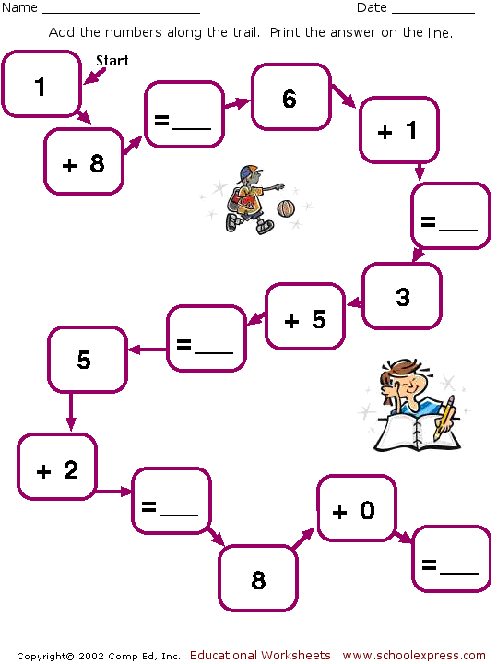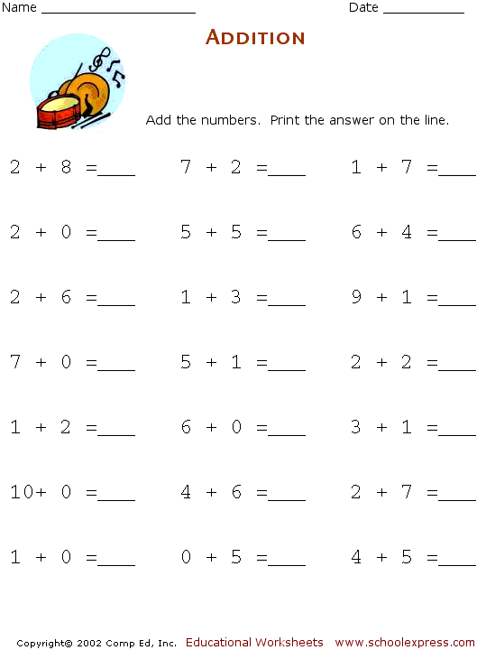

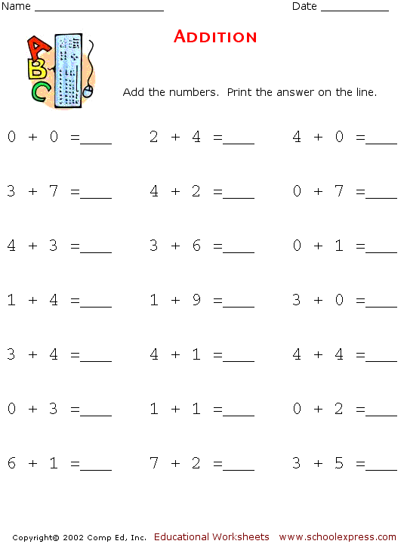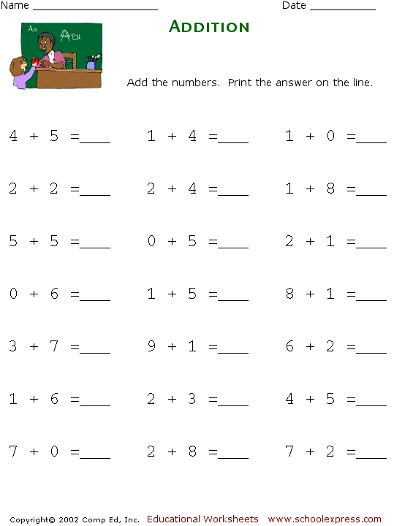



Συμπληρώνω τον αριθμό που λείπει για να είναι σωστές οι προσθέσεις.

1 + ……= 6 2 + …… = 6 3 + ……. = 6

4 + ……. = 6 5 + ……. = 6 6 + ……..= 6

…… + 2 = 6 ……. + 3 = 6 ……. + 4 = 6

……. + 1 = 6 …….. + 5 = 6 …….. + 0 = 6

1 + ……= 7 2 + …… = 7 3 + ……. = 7

HOME

4 + ……. = 7 5 + ……. = 7 6 + ……..= 7

…… + 2 = 7 ……. + 3 = 7 ……. + 4 = 7

……. + 1 = 7 …….. + 5 = 7 …….. + 0 = 7

TREE4

1 + ……= 8 2 + …… = 8 3 + ……. = 8

4 + ……. = 8 5 + ……. = 8 6 + ……..= 8

…… + 2 = 8 ……. + 3 = 8 ……. + 4 = 8

……. + 1 = 8 …….. + 5 = 8 …….. + 0 = 8

….. + 5 = 9 7 + ….. = 9 2 + ….. = 9

6 + ….. = 9 8 + ….. = 9 …… + 6 = 9

5 + ….. = 10 6 + ….. = 10 …… + 2 = 10

7 + ….. = 10 9 + ….. = 10 …… + 3 = 10

Συμπληρώνω τα μαγικά τετράγωνα.

|  |  |  |  |
| --- | --- | --- | --- |
| 2  **6** | 2 |  |  |
|  | 2 | 1 |  |
| 1 |  | 1 |  |
| 3 |  |  |  |
| 1 | 0 |  |  |

|  |  |  |  |  |
| --- | --- | --- | --- | --- |
| 1 |  | 2 |  |  |
|  |  | 3 |  |  |
|  | 1 |  | 1 |  |
|  |  | 2 | 0 |  |
| 1 | 1 | 1 |  |  |

|  |  |  |  |  |  |
| --- | --- | --- | --- | --- | --- |
| 1 | 2 | 1 |  |  |  |
|  |  | 1 | 2 |  |  |
|  |  |  | 3 |  |  |
| 1 |  | 1 |  |  |  |
| 2 |  | 2 |  |  |  |
|  |  | 1 | 0 |  |  |

**7**

**8**

**9**

|  |  |  |  |
| --- | --- | --- | --- |
| 2  **9** | 2 |  |  |
|  | 2 | 1 |  |
| 1 |  | 1 |  |
| 3 |  |  |  |
| 1 | 0 |  |  |

|  |  |  |  |  |
| --- | --- | --- | --- | --- |
| 1 |  | 2 |  |  |
|  |  | 3 |  |  |
|  | 1 |  | 1 |  |
|  |  | 2 | 0 |  |
| 1 | 1 | 1 |  |  |

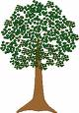

**10**

Συμπληρώνω τα κουτάκια για να φτιάξω τους αριθμούς που έχω στην κορυφή του πίνακα.

**9**

**8**

**7**

|  |  |
| --- | --- |
| **7** |  |
|  | **6** |
| **5** |  |

|  |  |
| --- | --- |
| **2** |  |
|  | **4** |
| **5** |  |

|  |  |
| --- | --- |
| **4** |  |
| **3** |  |
|  | **6** |

|  |  |  |
| --- | --- | --- |
|  | **9** |  |

|  |  |  |
| --- | --- | --- |
|  | **8** |  |

|  |  |  |
| --- | --- | --- |
|  | **6** |  |

1. Γράφω τον αριθμό που είναι πριν και μετά.

|  |  |  |
| --- | --- | --- |
|  | **7** |  |

Συμπληρώνω τον αριθμό που λείπει για να είναι σωστές οι προσθέσεις.

1 + ……= 10 2 + …… = 10 3 + ……. = 10

4 + ……. = 10 5 + ……. = 10 6 + ……..= 10

…… + 2 = 10 ……. + 3 = 10 ……. + 4 = 10

……. + 1 = 10 …….. + 5 = 10 …….. + 0 = 10

TRIKE1 + ……= 9 2 + …… = 9 3 + ……. = 9

4 + ……. = 9 5 + ……. = 9 6 + ……..= 9

…… + 2 = 9 ……. + 3 = 9 ……. + 4 = 9

……. + 1 = 9 …….. + 5 = 9 …….. + 0 = 9

1 + ……= 8 2 + …… = 6 3 + ……. = 10 5 + …..= 9

4 + ……. = 9 5 + ……. = 10 6 + ……..= 8 6 + …… = 8

…… + 2 = 6 ……. + 3 = 9 ……. + 4 = 9 3 + …… = 10

……. + 1 = 7 …….. + 5 = 8 …….. + 0 = 7 ……. + 2 = 9

Όνομα: …………………………………………………………………………………………………………………………….

Συμπληρώνω τα τετράγωνα έτσι ώστε το άθροισμά τους οριζόντια, κάθετα και διαγώνια να είναι ο αριθμός που είναι δίπλα.

|  |  |  |  |
| --- | --- | --- | --- |
| **2** |  |  | **10** |
|  | **3** |  | **10** |
| **6** |  |  | **10** |
| **10** | **10** | **10** | **10** |

|  |  |  |  |
| --- | --- | --- | --- |
| **2** |  |  | **9** |
|  | **3** |  | **9** |
| **1** |  |  | **9** |
| **9** | **9** | **9** | **9** |