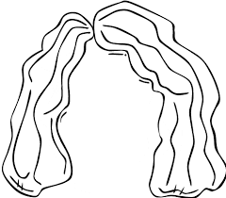**Πως περιποιούμαι τον εαυτό μου.**

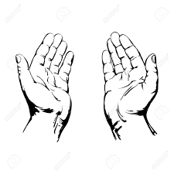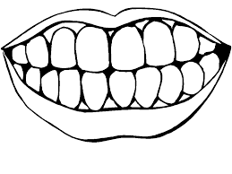

**δόντια**

**χέρια**

**μαλλιά**

|  |  |  |
| --- | --- | --- |
| http://thumb7.shutterstock.com/thumb_large/771868/101027371/stock-vector-soap-dispenser-freehand-drawing-icon-black-and-white-vector-illustration-101027371.jpg | http://thumb7.shutterstock.com/thumb_large/771868/101027371/stock-vector-soap-dispenser-freehand-drawing-icon-black-and-white-vector-illustration-101027371.jpg | http://thumb7.shutterstock.com/thumb_large/771868/101027371/stock-vector-soap-dispenser-freehand-drawing-icon-black-and-white-vector-illustration-101027371.jpg |
| http://images.clipartpanda.com/toothbrush-clipart-xcga8B7cA.png | http://images.clipartpanda.com/toothbrush-clipart-xcga8B7cA.png | http://images.clipartpanda.com/toothbrush-clipart-xcga8B7cA.png |
| http://sr.photos3.fotosearch.com/bthumb/CSP/CSP994/k15561293.jpg | http://sr.photos3.fotosearch.com/bthumb/CSP/CSP994/k15561293.jpg | http://sr.photos3.fotosearch.com/bthumb/CSP/CSP994/k15561293.jpg |