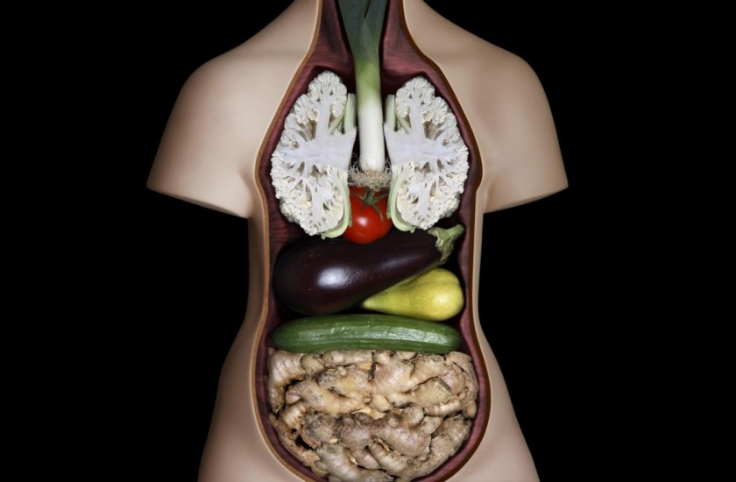

10 Foods That Resemble The Body Parts They Care For
28th January 2014

The human body is a big sagacity, a plurality with one sense, a war and a peace, a flock and a shepherd” – Friedrich Nietzche.
The human body speaks its own language, with which it advises us on how we should nourish ourselves in order to boost vitality of our body organs. The similarity between human body organs and some food items is not accidental by any means. Let’s have a look at some of the ‘food-looking’ body parts, or ‘body-looking’ food items:

1) Walnut – Brain
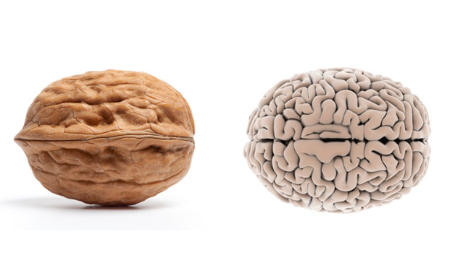
Walnut brain (via womensday.com)
Next time you go snack shopping during your exam period, try to avoid the crisps section and grab a pack of crunchy walnuts. Walnuts, that resembles left and right hemisphere of the human brain are full of omega-3s, which help to keep the brain fluid and flexible. The human brain is made of about 60% structural fat, which needs high-quality fats like omega-3s to work properly. Walnuts can also prevent you from becoming depressed and boost your mental well-being. So why not to get smarter and happier with a pack of walnuts
Eating Options: Walnut pesto, Walnut salad, Walnuts with Honey, Baklava, Walnut cookies
“You have brains in your head. You have feet in your shoes. You can steer yourself any direction you choose.” ― Dr. Seuss

2) Ginger – Stomach
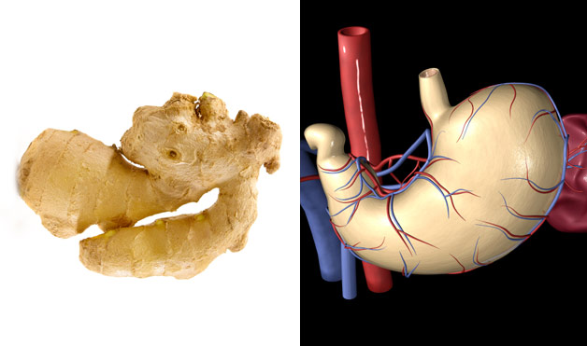
Ginger stomach (via womensday.com)
If you think that ginger was only made to accompany your favourite salmon sushi, you are very mistaken! Ginger root, which resembles the human stomach contains gingerols and shogaols, which have been shown to help treat upset stomachs, ease motion sickness, and relieve nausea and stomach flu. Ginger has always been one of the main ingredients in the Chinese, Japanese, Arabic and Indian cuisine as it helped to disinfect bacteria in the food and boost the digestion process.
Eating options: Ginger tea, ginger juice, ginger vegetable stir fry, ginger soup
“Indigestion is charged by God with enforcing morality on the stomach.” ― Victor Hugo

3) Carrot – Eye
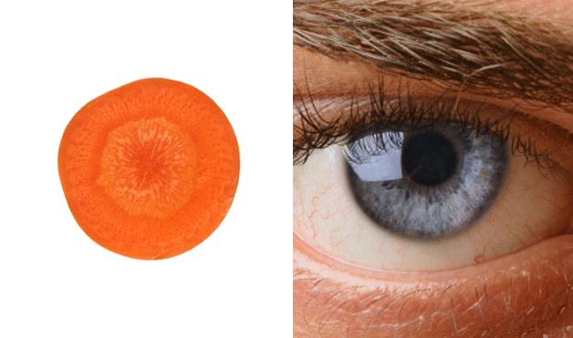
Carrot eye (via womensday.com)
When you slice a carrot, you will notice that the layers inside are very similar to the iris of the human eye. Carrots contain beta-carotene, which our body converts into Vitamin A, an important nutrient for the eye’s overall health. Deficiency of the Vitamin A can easily lead to eye dryness, swollen eyelids, corneal ulcers, or even blindness – well worth keeping an eye out for!
Eating options: Carrot cream soup, carrot salad, carrot-potatoes purée, carrot pie
“The eyes are the window to your soul.” ― William Shakespeare

4) Grapefruit – Breasts
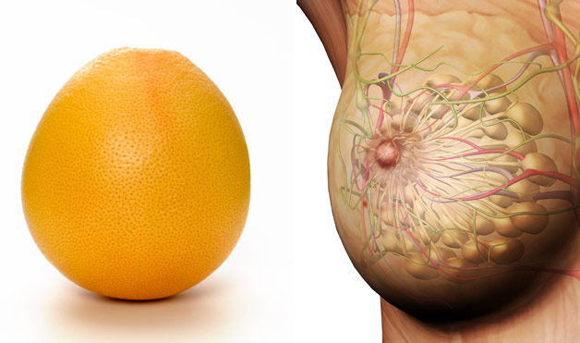
Grapefruit breast (via womensday.com)
Grapefruits contain natural compounds called limonoids that have been shown to help in fighting cancers, as they have the natural ability to induce the death of cancerous cells. Limonoids have also shown cytotoxicity to colon cancer, pancreatic cancer, liver cancer, neuroblastoma, leukemia, and many others.
Eating options: Grapefruit juice, salad with grapefruit, grapefruit brulée
“There’s a shortage of perfect breasts in this world. It would be a pity to damage yours.” ― Cary Elwes

5) Tomato – Heart
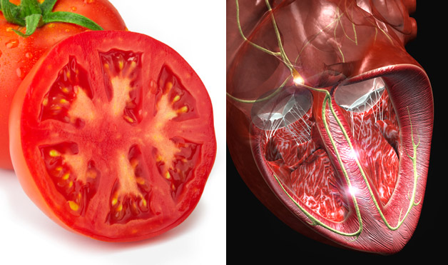
Tomato heart (via womensday.com)
When you cut a tomato in half, you will see many chambers that resemble shape of the human heart. Tomatoes are rich in lycopene, an antioxidant which helps to reduce the risk of heart disease and some types of cancer. Tomatoes are also rich in potassium, which is recommended to patients with high blood pressure as it helps to lower it. Vitamin B6 found in tomatoes also helps to convert the dangerous chemical homocysteine, which damages blood vessel walls, into other harmless molecules.
Eating options: Tomato soup, tomato juice, tomato sauce, tomato salad, salsa
“The way is not in the sky. The way is in the heart.” ― Buddha

6) Mushroom – Ear
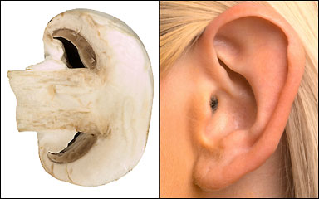
Mushroom ear (via smashinglists.com)
Mirroring the structure of a carrot, when you slice the mushroom in a half, you will see it resembles the shape of a human ear. Mushrooms contain Vitamin D which is essential for our bones, (as it helps the body to use calcium ) especially the tiny ones in the ear, which transmit sound to the brain. Research has also shown that most of the patients that are reported with bilateral cochlear deafness are associated with Vitamin D deficiency. If you suffer from hearing problems (apart from the ones that occur when your bank calls), supply your body with essential vitamins from mushrooms.
Eating options: Mushroom cream soup, stewed mushrooms, mushroom risotto
“The ear is the avenue to the heart.” ― Voltaire

7) Red Wine – Blood
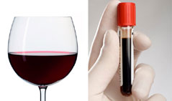
Wine blood (via womensday.com)
You don’t have to feel guilty about your staple evening glass of red wine anymore. Researchers found that red wine does not only resemble the natural colour of human blood, but it is rich in antioxidants and polyphenols, which prevent damage to blood vessels, reduces cholesterol, prevents blood clot formation, and protect the lining of blood vessels in your heart. Just make sure you don’t exceed your limit, and cheers to your health!
Eating options: Sangria, additional ingredients: risotto, venison
“Blood alone moves the wheels of history.” ― Martin Luther King

8) Avocado – Uterus
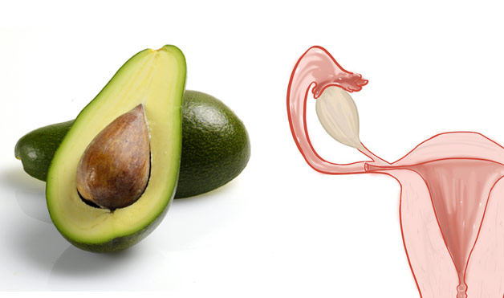
Avocado uterus (via womensday.com)
Aztecs called avocado the “fertility fruit” thanks to its big source of Vitamin E that balances the hormones, sheds off baby weight, and helps to prevent cervical cancer. It is very interesting that avocado not only resembles baby in the womb, but it also takes exactly 9 months for one avocado to blossom to a ripe fruit.
Eating options: Guacamole, avocado salad, avocado soup, avocado fajita
“There is no other organ quite like the uterus. If men had such an organ they would brag about it. So should we” ― Ina May Gaskin

9) Celery – Bones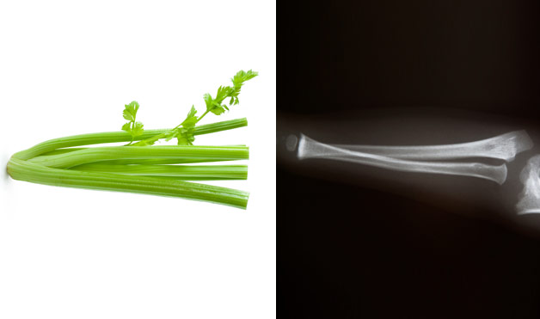

Celery bones (via womensday.com)
Celery contains the essential mineral calcium, which is vital for the development and maintenance of strong and healthy bones. Celery also contains Vitamin K, which suppresses the decrease in spinal bone mineral density and helps to prevent bone loss that every woman experiences during menopause. Whether you serve it raw, crispy or cooked, celery will enrich your body with phytonutrients, minerals and vitamins.
Eating Options: Celery soup, stewed celery, celery salad, celery juice
“I have no history but the length of my bones.” ― Robin Skelton

10) Banana – Lips
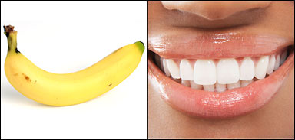
Banana lips (via smashinglists.com)
Does the half-moon shape of one of the sweetest fruits remind you of something? Banana contains an amino acid called tryptophan which, when digested, turns into serotonin. Serotonin is known as our “mood neurotransmitter” and keeps us emotionally and socially stable. So next time you’re doing your weekly food shop, don’t take the good old banana for granted, grab one and cheer yourself up with this delicious fruit.
Eating Options: Bananas with honey and walnuts, banana with rice and meat (Cuban cuisine), banana split
https://urbantimes.co/2014/01/foods-which-resemble-body-parts/

