Art Appreciation Assignment in English
Title of Painting: The Scream
Artist: Edward Munch
Dimensions: 91cm x 74cm
Medium: Oil paints, tempera, and pastels
Student’s Name: Christina Ntigrintaki, Maria-Laura Beshiri, Gregory Micheletakis, Aggelos Mitsopoulos

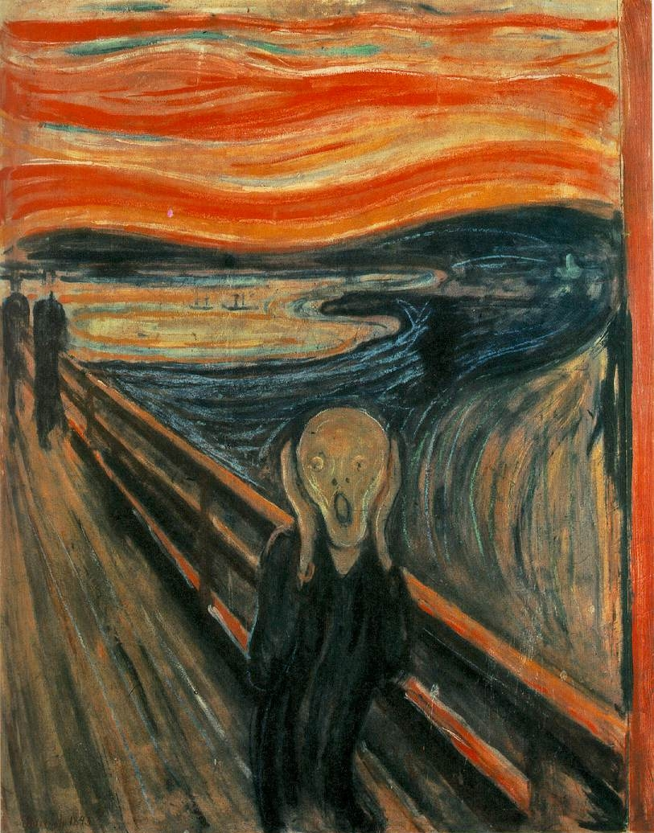

PART I) DESCRIPTION:

- What were the first things you noticed about this painting?
We were first struck by the intense colours that the artist has used in this painting, and then by the terrified figure standing in the middle of nowhere and screaming.

- What can you see in the painting?
In the foreground there is a moving figure who is standing on a bridge and screaming, while in the background there are two walking human shadows which are not emphasized. Moreover, in the background there is the sea or a river and a dramatic sunset.

- What mood does the painting convey?
Generally we think the painting conveys a depressing feeling, as the moving figure looks terrified, lonely and exhausted. Also, the intense colours and the blood on the railings suggest violence and the end of someone’s life. What is more, there are dark colours like black and blue that stand out.

- Do you think the artist is trying to make a statement (personal, political, social) in this artwork?
Yes, we think the artist is trying to make a personal statement about his own life and the difficulties he’s facing and a social comment on the confusing and depressing nature of human life in the context of society.
- Does the artwork have any historical significance? If yes, what is it?
No.
- Has the artist included any symbols in the artwork? If yes, what are they?
Yes, the scream symbolizes despair and isolation while the dark colours represent anxiety, intensity and stress. The bridge is also a symbol of transition to another place, or another life.

PART II) ANALYSIS:
7. How has the artist used colour? How does it make you feel?
The artist has used lots of complementary colours, like blue, yellow, red and orange together. These contrasting colours emphasize certain areas in the painting. They make us wonder about the feelings the figure may have. They definitely convey an aura of melancholy and despair, which is transferred to the viewer.

8. How are shapes and lines used?
The vertical lines of the bridge create some order among the chaos and a sense of reality and safety. On the other hand, the shapes in the background are blurred and unrecognizable. Moreover, the figure of the man is strange and uneven, being a visual expression of his chaotic and desperate feelings.

9. Is the composition of the painting successful? Why/Why not?
Yes. We think the screaming figure is the main focus of the composition, as it provokes strong emotions like depression, sadness, anxiety and despair. Also, the lines of the sunset are blurred and, as a result, they have a confusing effect on the viewer and his emotions.

10. Any further comments, likes, dislikes?
We like the way the artist has applied the colours in the painting. What is more, we think that the sunset may symbolize the end of his life and that makes the painting more interesting and unforgettable to the viewers.

